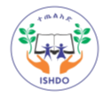
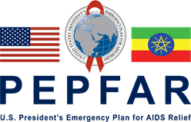
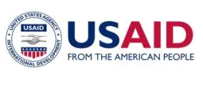


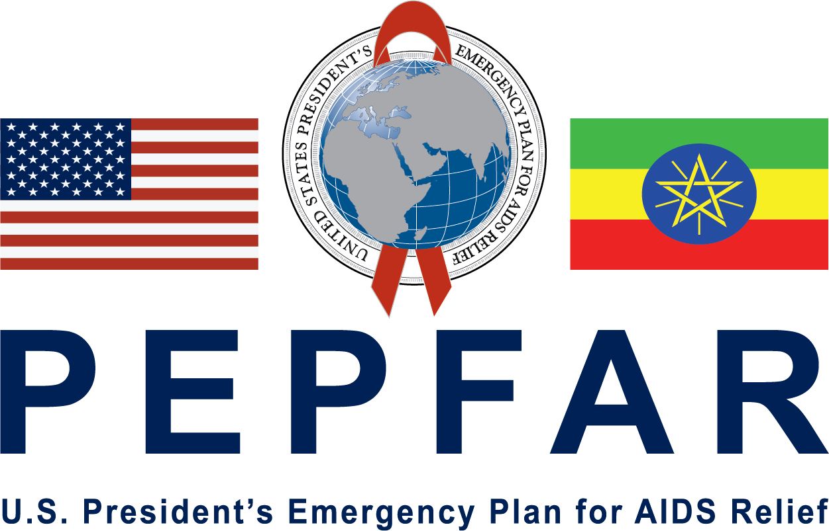
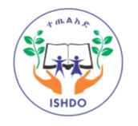
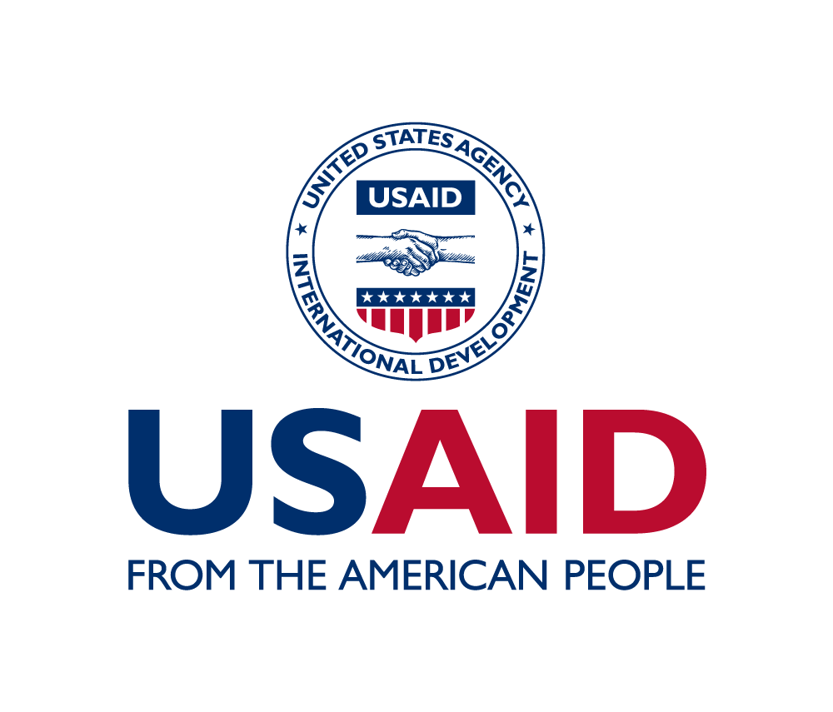

USAID/PEPFAR Ethiopia In-Country Reporting System (IRS)
Reporting Template

Integrated Service on Health and Development Organization (ISHDO)

program results
for

Fiscal Year 2021,
SEMI ANNUAL PROGRESS REPORT

(October 1,2020 to March 31, 2021)

CONTACT INFO FOR THIS REPORT:

Dr Girmachew Mamo
Chief of Party
+251911226097

LIST OF ACRONYMS

APC
Area Program coordinator
ART | Anti-Retroviral Therapy
C/ALHIV | Children and Adolescents living with HIV
CAG | Community ART Refill Groups
CEF | Community Engagement Facilitator
COP | Chief of Party
CWs | Case Workers
FFHPCT | Family Focused HIV Prevention, Care and Treatment
FIDO | Fayyaa Integrated Development Organization
HF | Health Facility
HIV | Human Immune Virus
ICT | Index Case testing
ISHDO | Integrated Service on Health and Development Organization
LIP | Local Implementing Partners
LTFU | Loss to Follow Up
MENA | Mekdim Ethiopia National Association
MMD | Multi Month Dispensing
MOU | Memorandum of Understanding
NTCBCO | Nekempt Charity based community Organization
ODA | Oromia Development Association
OVC | Orphan and Vulnerable Children
PEPFAR | President’s Emergency Program for AIDS Relief
PLHA | People Living with HIV AIDS
SNUs | Sub National Units
SSWs | Social Service Workers
TOI | Trainers of Instructors
USAID | United states Agency for International Development
VL | Viral Load
VLS | Viral Load Suppression

TABLE OF CONTENTS

1. Reporting period 4
2. Publications/reports 4
3. Technical assistance 4
4. Travel and Visits 4
5. Activity 5
6. Accomplishments and successes during the reporting period 16
7. Challenges, Constraints and plans to overcome them during the reporting period…...18
8. Data Quality issues during the reporting period 23
9. Major Activities planned in the next reporting period 24
10. Environmental compliance 26
11. Financial accomplishment…………………………………………………………...26
11. Issues requiring the attention of USAID Management 26
12. Data Sharing with Host Government: 26
13. Appendices 27

1. Reporting period

From October 1,2020 | To March 31,2021

2. Publications/reports
Did your organization support the production of publications, reports, guidelines or assessments during the reporting period?

No/Not Applicable
Yes If yes, please list below:
Publications/Reports/Assessments/Curriculums
Title | Author | Date

If Yes, please attach an electronic copy of each document as part of your submission.

3. Technical assistance
Did your organization utilize short-term technical assistance during the reporting period?
No/Not Applicable
Yes Please list below:

Consultants/TDYers
Name | Arrival | Departure | Organization | Type of Technical assistance provided

If Yes, Please attach an electronic copy of the TA report as part of your submission.

4. Travel and Visits
Did your organization support international travel during the reporting period?

No/Not Applicable
Yes Please list below:
International Travel (All international travel to conference, workshops, trainings, HQ or meetings).
Name | Destination | Departure from Ethiopia | Arrival | Host Organization | Purpose of the travel

Have any Monitoring Visit/supervision been made to your program in during the reporting period?

Description of Monitoring team | Start date | End date | Sites visited | Written recommendations provided
COP, HIV service director | Nov 6,2020 | Nov 6,2020 | Meki | Yes
HIV specialist and M&E officer | Dec 12, 2021 | Dec 13, 2021 | Sebeta | Yes
HIV specialist, M&E Specialist, Area PC | Dec 12, 2020 | Dec 13, 2020 | Burayu | Yes
USAID Activity Manger, APC Adama | Dec 16,2020 | Dec 17,2020 | Bishoftu | Yes
APC Ambo and HIV officer | Dec 21,2020 | Jan 01,2021 | Ambo, Burayu, Holeta, AdaBerga, Jeldu & Dendi | Yes
APC Adama, HIV officer | Dec 21,2020 | Jan 01,2021 | Shashemene, Goba & Bulehora | Yes
M&E specialist | Dec 21,2020 | Jan 01,2021 | Adama and Bishoftu | Yes
OVC officer | Dec 21,2020 | Jan 01,2021 | Nekempt Gimbi, Nedjo | Yes
HIV specialist and M&E officer | Dec 21,2020 | Jan 01 ,2021 | Sebeta, Woliso, Fiche, Kuyu, Sululta & Becho | Yes
OVC C&S specialist HIV officer | Dec 21,2020 | Jan 01,2021 | ODA Modjo, Bishoftu & Dukem | Yes
Area PC and OVC Officer | Jan 13, 2021 | Jan 16, 2021 | Goba & Shashemane | Yes
ISHDO HIV specialist | March 1, 2021 | March 5, 2021 | Jimma, Agaro, Bedele and Metu | Yes
HIV Service officer | March 8, 2021 | March 27, 2021 | Goba, Shashemene, Bule Hora, Yabello, Adola, Nagele Borana and Shakiso | Yes
Cluster OVC officer & Cluster HIV officer | March 8, 2021 | March 27, 2021 | Nekemt, Dembidolo and Nedjo | Yes
ES Officer, CS Officer, M&E Specialist & Area PC | March 9, 2021 | March 9, 2021 | Shashemene | Yes
ES Officer, CS Officer, M&E Specialist & Area PC | March 15, 2021 | March 16, 2021 | Goba | Yes
HIV service specialist & Community Engagement Facilitators/CEFs | March 23, 2021 | March 24, 2021 | Robi & Ginir | Yes
HIV service specialist & CEFs | March 26, 2021 | March 26, 2021 | Bishoftu and Modjo | Yes
ISHDO HIV specialist, M&E Specialist | March 23, 2021 | March 24, 2021 | Woliso | Yes
ISHDO HIV specialist | March 29, 2021 | March 30, 2021 | Bishoftu | Yes
Cluster OVC officer & Cluster HIV officer | March 8, 2021 | March 27, 2021 | Nekemt, Dembidolo and Nedjo | Yes

5. Activity
Program Area  (Tick all which apply) | Activity ID | Activity Title (Please write the title of the activity)
01-PMTCT
02-HVAB
03-HVOP | 72066320CA00013 | Family focused HIV prevention, care and treatment activity in Oromia
04-HMBL
05-HMIN
07-CIRC
08-HBHC
09-HTXS
10-HVTB
11-HKID
12-HVCT | 72066320CA00013 | Family focused HIV prevention, care and treatment activity in Oromia
13-PDTX
14-PDCS
15-HTXD
16-HLAB
17-HVSI
18-OHSS

6. Accomplishments and successes during the reporting period

Project Overview
Family focused HIV, prevention, care and treatment activity is a USAID funded activity Implemented by ISHDO and its partners in Oromia region for the period of Oct 2020 to September 2023 with a total budget of USD$ 9,828,785 million.

The main purpose of the activity is to strengthen HIV epidemic control so that 95% of individuals living with HIV know their status, 95% of persons living with HIV initiate antiretroviral therapy and 95 % of clients on antiretroviral therapy achieve viral load suppression by 2030.

This community HIV Care and Treatment activity aims to accelerate and sustain HIV epidemic control in Ethiopia through assisting delivery of high-impact community-based HIV services and support community-based case finding through ICT, tracing of LTFUs, HIV self-testing, provision of referral to HF for care and treatment services and support the establishment of community ART refill groups.
The project also implements a high quality OVC program that is aligned with new direction and priorities of PEPFAR OVC programs emphasizing on Comprehensive Case management and Primary Prevention of violence and HIV among 9-14-year girls and boys in line with PEPFAR technical Capacity domains for prime partners.

USAID family focused HIV prevention, care and treatment activity will support the implementation of Community HIV care and treatment services, comprehensive HIV service for OVC and primary prevention for adolescent aged 9-14 in 41 woredas/towns of Oromia National Regional State.
This project is implemented as prime by integrated service on Health and development Organization and 6 sub local implementing partners namely
1) MENA,
2) DUGDA,
3) ODA,
4) FIDO,
5) HUNDEE
6) NTCBCO and ISHDO in selected 41 woredas /towns of Oromia regional state towns and collaboration with major regional stakeholders’ Bureaus of Health, Education, Women Children and Youth, Labor and Social affairs and Finance and Economic Development.

Overview of FY21 SAPR

The first quarter is the startup period for the FFHPCT which involved the engagement of partners development of detail work plan and budget, cascaded to implementing partners in the partners in an orientation and plan development workshop and finalization of agreement with sub partners.
Staffing of the project was another important step for the startup. ISHDO and partners have recruited the necessary staffs required for the project using competitive process and most of the staffs were on Board and started their activity at the project sites.
Program area orientations and technical trainings on ICT, MMD, CAG, commcare application’s, CHCT and OVC case management, and TOI on Impower and synovio prevention curricula were provided refresher training to SSW virtually and in person by technical partners Project Hope, FHI-360 and ESSSWA Technical partners and implementing partners have moved very fast in continuing services started in the previous projects. FHI360 also organized a number of virtual orientations and trainings to equip partners with necessary knowledge to startup services on comprehensive OVC programming.
Along with ESSSWA additional PEPFAR approved Prevention curricula entitled Coaching Boys into Men (CBIM) is reviewed, adopted and introduced to complement delayed Prevention curricula implementation. ESSWA has played a significant role in material translation to Amharic and Oromiffa, rollout of the TOT.
ISHDO, based on the training provided by TA partners cascaded the training to partners, mostly in the second quarter. ISHDO cascaded the training to over 100s of specialists, officers, CEF and SSW has been trained on various subjects to enhance their knowledge and skills on the subject matter. Accordingly, the IPs have also cascaded the training to their Volunteers (case workers) and the training was supervised by ISHDO as prime.
ISHDO in collaboration with Project Hope has also conducted a joint integrated Supportive supervision in selected ISHDO and partners implementation towns using a structured checklist conducted verifications of data (CHCT/ICT data) and provided feedback for improvement.
ISHDO has also provide onsite TA support to partners who have been lagging in performance through the USAID activity manager, Area program teams and central team staffs.
ISHDO has devised and acceleration and catchup plan to track performances and conducted daily tracking of targets and weekly virtual review of performances and quarter review meeting in person to review performance and develop plan to improve performance in areas where major gaps are observed.
Accordingly, ISHDO and partners have provided and conducted HIV testing serviced through ICT and HIVST through community and facility-based modalities to intensify case finding and enrolled into treatment.
ISHDO and partner has also Identified vulnerable children & families and enrolled over 50,000 eligible children & families into care , assessed, developed care plan and provided need-based package of services .
ISHDO and partners have been closely working with target towns health authorities, facilities, PLHIV association and community structures like CCC signed MOU and using that collaboration used to facilitate HIV testing, care ,support, and treatment services and follow-up for the targeted beneficiaries.
The major Achievements in this period is as follows
FY2021, SAPR FFHPCTA key performance indicators
- Elicited 7760 contacts of index cases using line list collected from facilities and communities.
- Tested contacts of 7441 contacts of Index cases
- Identified 400 HIV positives cases from the contacts identified.
- 372 (37.4% of SAPR target) HIVST kits distributed to beneficiaries
- 24 (6.5%) HIV positives identified through HIVST.
- Identified 654 LTFU cases line listed from Health facilities,
- 570 (87.2%) were tracked and re-engaged,
- 54 CAG/PCAD groups having 293 members were established and refilled.
- 52,134(98%) OVC enrolled into Comprehensive care.
- 26,495 caregivers were enrolled into care.
- 4,073(98.4%) children and adolescents living with HIV were enrolled into care.
- 619 adolescent girls were reached on IMpower curriculum.
- 1878 adolescents and 1874 caregivers were reached through Sinovuyo curricula.
- 463 Adolescent Boys were reached through Coaching Boys (CBIM) into Men curricula.

FY2021, Semi-annual FFHPCTA key achievements

Result 1: Increased access and demand to family-focused HIV services that reduce HIV
IR 1: HIV testing and counseling in the community
1.1 HIV case finding through ICT

HIV case finding remains a critical gap to meet the first of the three 95 targets ser by UNAID and nationally. ISHDO and its partners conducted HIV testing service in the community and in collaboration with public health facilities.
HIV testing using health facility as well as community-initiated ICT was done for 5436 children and adults and 289 HIV positive cases were identified.
Of 3717 index HIV+ cases, 2754 contacts were elicited of which 5641 were tracked and found. Of the elicited contacts, 75 were not found while 38 are still being traced. 204/5641 refused testing. The remaining 5436 were tested for HIV. An average of 1.5 people was elicited per index case. The testing cascade is shown in Figure 1 below.
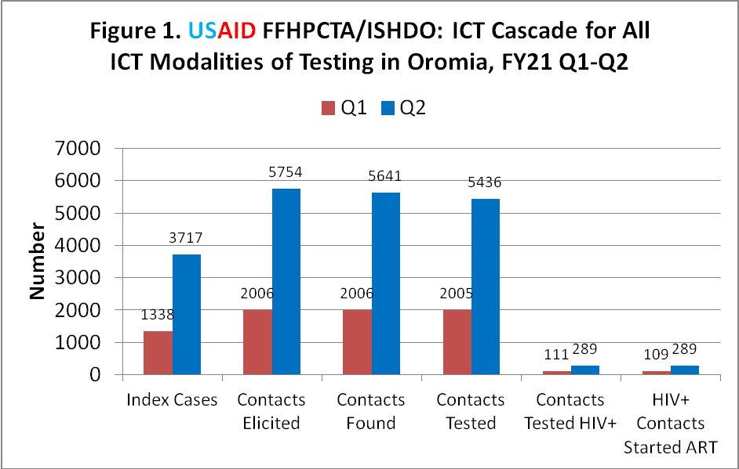
During this reporting period, in the ICT cascade 5055 index cases were identified from community and facility through line list ,7760 contacts were elicited from the index cases ,7647 contacts were found and out of which 7741 contacts were tested and 400 (5.4% yield) and 398(99.5%) linked to treatment.
Community based ICT HIV testing is 5097 for the semi-annual period (868 during Q1 and 4229 during Q2) which is 36.9% of the semi-annual target. Similarly, 165 HIV+ cases were identified (38 during Q1 and 127 during Q2) making the progress at 7.6% of the annual target for new HIV+ detected through community-based testing. (Figure 1)

The overall testing volume especially for community-based test was low due to the limited test kits accessories and supplies to do community-based testing.

Establishing well-functioning relationship with health facilities also took some time to mature contributing to low testing as well.

Despite the carious efforts is the short period to use innovative solutions for maximize yield and testing, testing yield continues to be low especially for clients recruited from the community at 3.9% compared to health facility-initiated ICT which is at 9.1%.

The attributing factor for low testing yield is then loose application of risk assessment tool by CEFs at community level compared to health facility level. Coaching will continue to focus on this area for community workers to improve the yield.
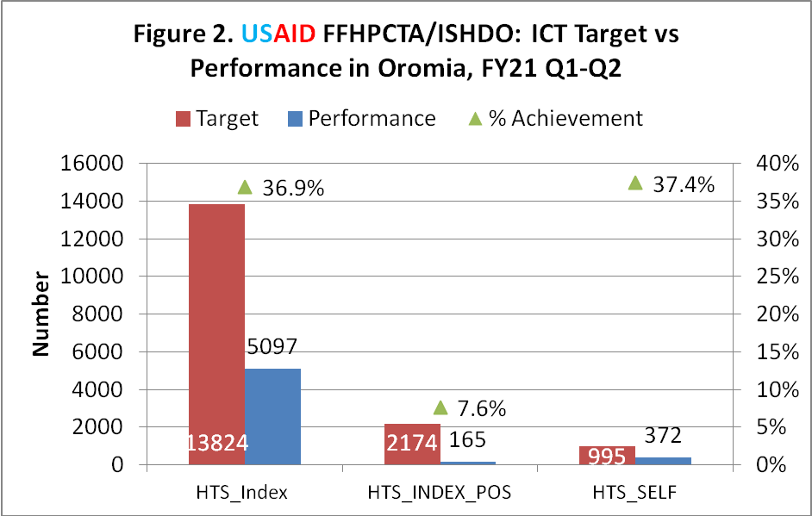

The overall ICT testing and case finding is low during this reporting period. The achievement as compared to the target is significantly low ,36.9% Vs 50% target for testing and positive case finding is 7.6% Vs 50% target.
The attributing factors for low testing and yield is late startup of program activities, limited access to HIV test kits and accessories and limited experience of Community workers on the innovative techniques on ICT
ICT testing trend by quarter (Figure 3) indicates that overall testing improved by 2.7 times during Q2 compared to Q1. This is the result of accelerated case finding activity implemented that involved orientation of IPs and initiation of case finding activity in most SNUs in addition to daily and weekly tracking of case finding activity. HIV testing yield is more or less the same during Q1 and Q2 as shown in Figure 2 below.

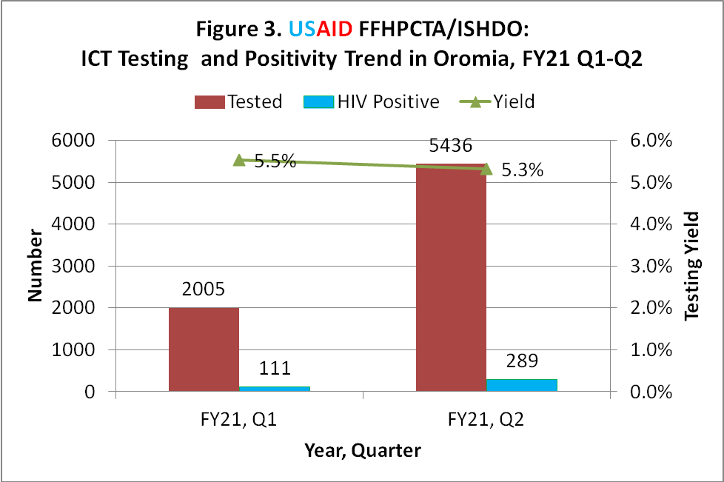

ICT testing yield trend by type of person tested across quarters indicates that testing yield is more or less the same both for children and spousal/non-spousal partners. The use of ICT risk assessment tool to prioritize testing of children of newly diagnosed adults and high risk adults is not being properly implemented and that was the reason why the yield is stalling at the same position. (Figure 4)

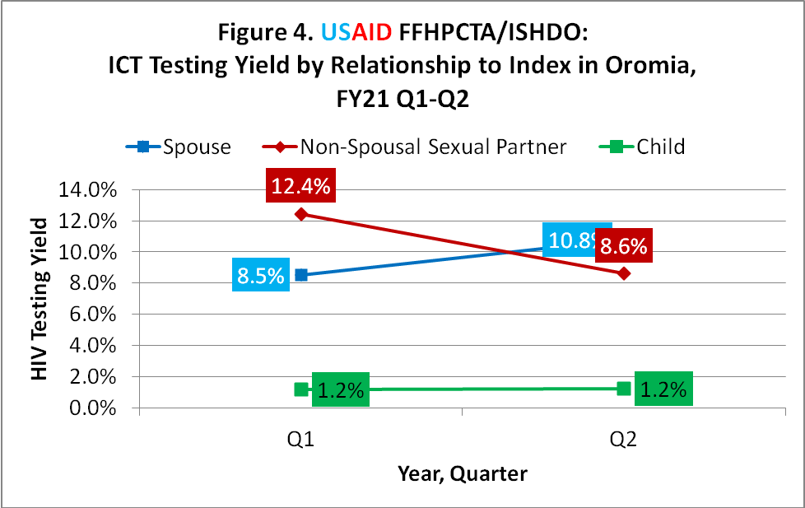
HIV testing yield by the type of relationship of the contact to the index during Q2 indicates that 2744 children tested for HIV, with 1.2% yield; of 1067 spousal partners, 10.8% were found to be HIV positive while for non-spousal sexual partners, 1625 were tested at 8.6% yield.

The testing and case finding trend has increased by double in second quarter as comapred to the first quarter despite slow progresses towards the target. Better access to commuity testing with better avaiability of test kits and acess to training for community workers on ICT and PNS has brought this progress todate.

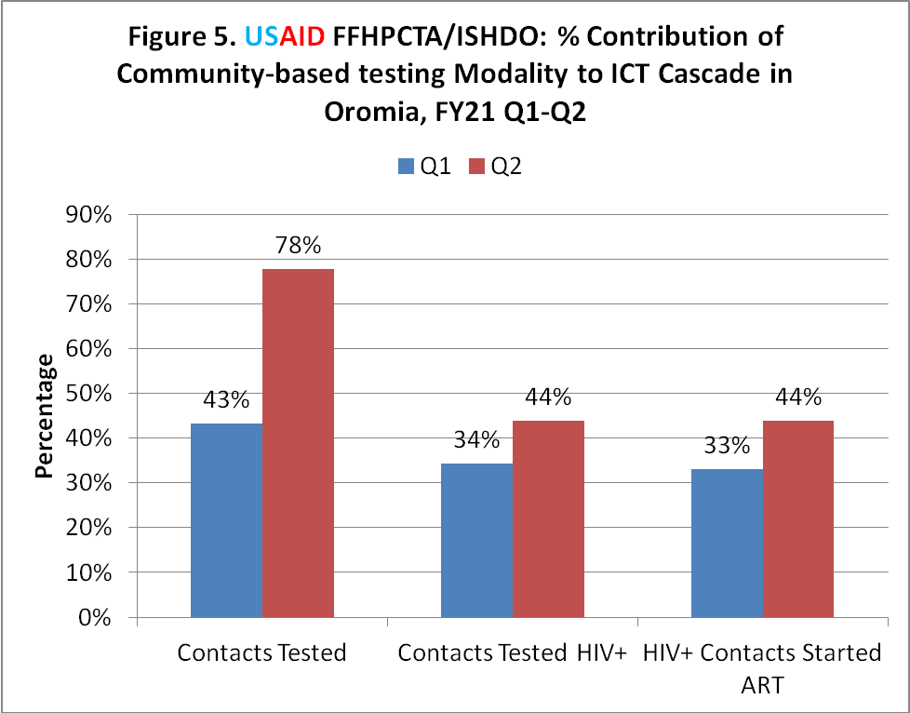

The relative contribution of the community based index case testing using rapid HIV test kits is shown in Figure 5 below. 78% ICT testing during Q2 was done through community based testing comared to 43% during Q1, During the same time, health facility based testing decreased from 48% to 19% and the contcats tested in the community based testing increased from 34% to 44%

Figure 5 Shows the overall contribution of testing modalities. ICT index, contacts elicitation and contacts tested cascade has increased almost by double as compared to the first quarter. for contacts tested HIV + still majority of HIV positives cases comes from the health facility. we are doing detail analysis on this issue to leverage practices for higher yield outcomes from facility.

HIVST contribution to case finding has dropped significantly from 10% in quarter 1 to 2% in quarter two which is attributed to availability of alternative convention test kits for the community test bust may need further investigation for low utilization of HIVST and low yield.

1.2 HIV case finding through HIV self-testing

HIV self-test is being used as an alternative for case finding in community-based setting. A total of 181 HIV Self tests were distributed during Q1 and 191 in Q2. This makes the total kits distributed during this reporting period to be 372, which is 37.4% of the semi-annual target. 4 out of the 372 tests during this reporting period ere unassisted while the rest 187 were assisted. (Figure 2 above) Most HIV Self-test kits are distributed to the same SNUs where rapid tests are available making their use redundant. That is the reason behind the low utilization rate. Redistribution to sites where there is shortage or incomplete allocation of all three rapid tests will likely improve use.

All HIV test results for self-tests were disclosed with 6 HIV+ cases identified, 1 through unassisted self-test. All HIV positive cases identified through self-test received confirmatory test and the result was consistent between self-test and rapid test.

1.3 Active Linkage to Care and Treatment

Linkage to treatment for all 289 newly diagnosed HIV positive cases during Q2 was successful at 100%. Overall in the semiannual period the linkage was 99.5%(Figure 1)

1.4 Geographic and demographic hot- spots identification
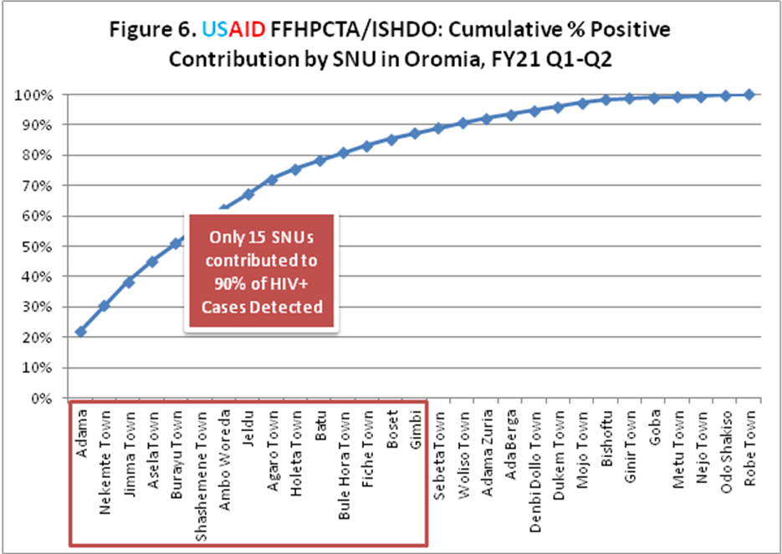
Figure 6 below is a Pareto chart that shows the cumulative proportion of HIV+ cases newly diangosed by SNU. 15/30 SNUs that reported ICT testing, accounted for 90% of the new HIV+ cases diagnosed. Case finding will accelerate during Q3 in these SNUs while the other SNUs will be supported to deliver more.

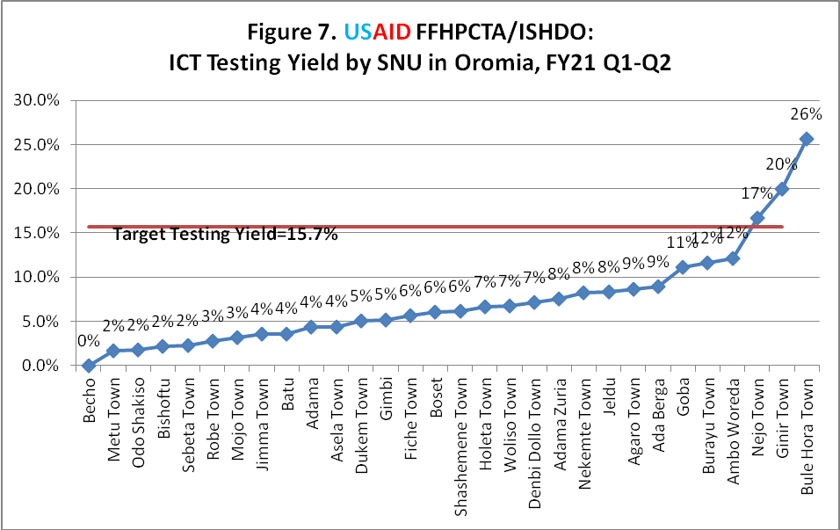
Figure r shows that ICT testing yield by SNU indicating high testing yield in four SNUs where yield of >16% was recorded. (Figure 7). This high testing yield further analysis showed that it is attributed to testing of back log of high risk contacts which can be further leveraged in all SNUs that just started implementing ICT.

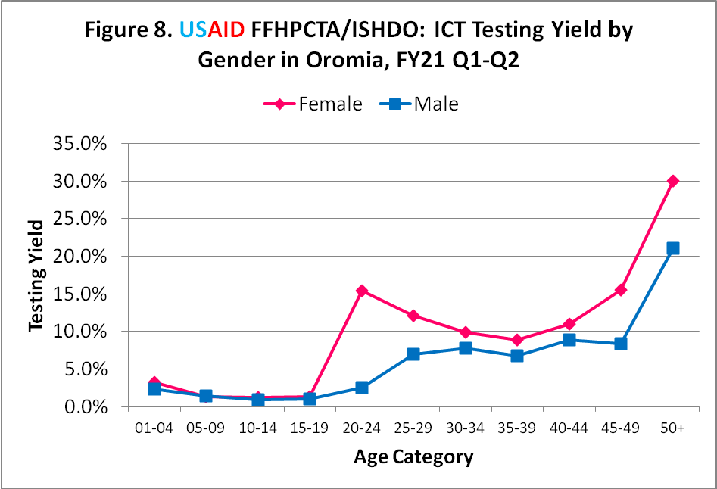

Testing yield by demographic factors is indicated for age and gender in Figure 8. Age and gender differences are seen clearly with women in the age groups 20-24 and 50+ having a much higher positivity rate comapred to men. Men in the age group 50+ were also seen to have high positivity rate.

1.5 ICT and case management Trainings

During this reporting period, ISHDO with support from Project Hope has received TOT trainings to ISHDO TA support staffs to be cascaded to Implementing partners . The trainings provided hands on knowledge on ICT& PNS, case management, recency testing. The training has applied practical application techniques for case finding, ICT case management and community ART refill groups formation, follow-up support and reporting.
The recency testing training was done in collaboration with Adama and Nekempte regional laboratories who facilitated the theoretical and practical application of the training.
Table 1. List of TOT trainings provided under FFHPCT by TA partner

Training Type | Training Provider | Dates of the training | Sex |  | Participants of sub partners
Training Type | Training Provider | Dates of the training | Male | Female | Participants of sub partners
TOT ICT&PNS | Project HOPE | December 24-31, 2020 | 8 | 5 | HUNDEE, ISHDO, MENA, ODA a DUGDA, NTCBCA, FIDO
Comprehensive CHCT TOT | Project HOPE | January 11-16, 2021 | 4 | 3 | ISHDO and partners
Comprehensive CHCT TOT | Project HOPE | January 20-25, 2021 | 6 | 4 | ISHDO and partners
Recency testing (TOT) | EPHA | February 1-5, 2021 | 2 | 0 | ISHDO
Recency testing | Nekempte Regional Lab | February 26-27, 2021 | 7 | 5 | NTCBCA, ISHDO, FIDO
Recency testing | Adama regional Lab | March 5-6, 2021 | 18 | 6 | HUNDEE, ISHDO, MENA, ODA and DUGDA
CAG TOT | Project HOPE |  | 14 | 7 | HUNDEE, ISHDO, MENA, ODA and DUGDA, NTCBCA, DO

Following the TOT conducted by PH. ISHDO has facilitated the cascade of the training to Implementing partner specialists, officers and CEFs reaching pool of trainers who can cascade to Volunteers.
Table 2: List of TOT trainings cascaded under FFHPCT by ISHDO

Training Type | Training provider | Date of the training | Sex |  | Participants of sub partners
Training Type | Training provider | Date of the training | Male | Female | Participants of sub partners
CHCT/CM | ISHDO Prime | February 21-23, 2021 | 16 | 3 | DUGDA, HUNDEE, ISHDO , ODA
ICT and PNS | ISHDO Prime | February 18-20, 2021 | 13 | 5 | DUGDA, HUNDEE, ISHDO and ODA
ICT and PNS | ISHDO Prime | February 18-20, 2021 | 7 | 7 | ISHDO, FIDO, MENA ,NTCBCA
CHCT/CM | ISHDO Prime | February 21-23, 2021 | 8 | 5 | DUGDA, HUNDEE, ISHDO and ODA

IR 2: Increased adherence and retention on ART through targeted community case management including adherence counseling and support, disclosure, and psychosocial services for PLHIV

2.1 Ensuring adherence of ART clients

Tracing of lost to follow-up (LTFU) cases was done as shown in Figure 9 below. Of 654 LTFU cases line listed, 570 (87.2%) were re-engaged, while 5 were found to be already on treatment, 9 were self transferred-out cases, while 12 were confirmed dead.

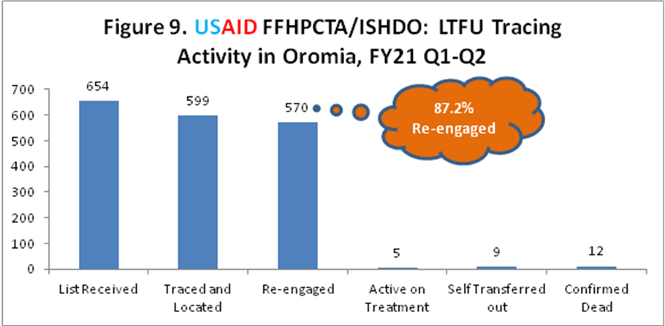

2.2 Strengthening bi-directional referral system

For LTFU cases traced and located, adhernece barrier analysis indicates that patient related and socio-economic factors were main reasons for discontinuing treatment (Figure 10) and for that appropriate services were provided for those and other issues through bidirectional referral.

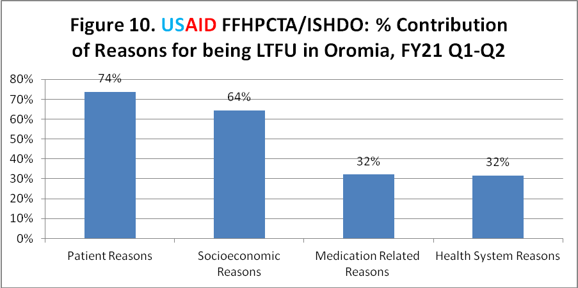

2.3 Demand creation for GBV and cervical cancer screening

Demand creation and screening for cervical cancer was also done for women with HIV. Accordingly, 482 women were counseled on the need for screening of which 201 received screening and 8 were found to have cervical cancer.
In addition, 25 cases of gender-based violence were referred for legal and medical support. All enrolled children and caregivers were screened for occurrence of gender-based violence (4073 HIV+ children and 10436 HIV+ caregivers).

Sub IR 2.1: Implement community-based differentiated care model, including healthcare worker managed groups and adherence peer led groups to improve adherence and retention on ART and achieve viral load suppression.

2.1.1 Implementation of community-based differentiated care model

Community ART groups were established in selected high load ART facilities. only, 3 CAG groups having 15 members were established in the 2 quarter. It is one of the challnging area with big underpereomance attributed to lack of guidance from ORHB in terms of sharing facility targets and reporting mechanism, most HEWs and ART focal workers are reluctant to start the activity. In addition, 51 PCAD groups having 278 members were established. This is 7.9% of 684 CAG and PCAD groups expected to be established during the semi-annual period and 7.1% of 4106 members expected during the same period.
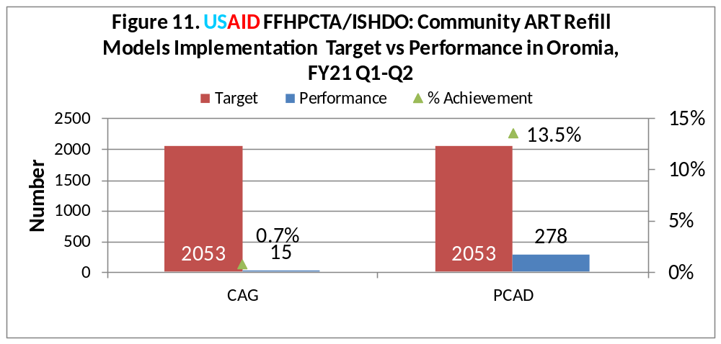
A total of 335 participants were trained on Community based DSDM models from health facility, HEWs, and different health offices. Despite that, there is reluctance to implement it by these key stakeholders becuas eof lack of clear guidance from regional health bureau. Lack of regional task force to oversee this activity is the major issue why there is gap and getting that established will be a priority for Q3.

IR1.3 Increased access to high impact community-based services for OVC & HIV prevention

3.1 Implement Comprehensive OVC intervention
    - Support to Community Care Coalitions (CCCs).
FFHPCTA strengthened the capacity of IPs to support CCCs in leveraging community resources for OVC households by providing technical assistance on micro-planning and resource mobilization strategy development and implementation.
As a result of these efforts, IPs supported 82 CCCs in the reporting period which raised cash and in-kind resources worth 3,197,275 Birr (US$ 77,982) in this reporting period. From the total resource mobilized with in the quarter 3,039,556 Birr ($74,135) was utilized to support OVC and caregivers enrolled in FFHPCTA. The resources raised were used to benefit 12,208 OVC and 6,648 caregivers enrolled in the FFHPCTA program with services.
These resources, donated by private business owners, schools, government sectors, Idris, religious institutions, and NGOs, included establishing VSLA, cash transfer, scholastic materials, school fee exemptions, free medical services, clothes, food items, waivers on rent for kebele homes, and sanitary materials for COVID-19 prevention.
Table 3: Resources Mobilized by CCCs to Support OVC households

IPs Name | Resources Mobilized (Eth Birr) |  |  | Beneficiaries Benefited
IPs Name | In-Cash | In-kind | Total | <18 | >18 | Total
Dugda | 144,006 | 345,275 | 489,281 | 2,502 | 1,393 | 3,895
FIDO | 190,750 | 800,170 | 990,920 | 2,049 | 553 | 2,602
HUNDEE | 145,273 | 296,000 | 441,273 | 297 | 244 | 541
ISHDO | 2,400 | 242,800 | 245,200 | 1,522 | 836 | 2,358
MENA | 168,760 | 284,256 | 453,016 | 1,411 | 695 | 2,106
NTCBCA | 34,333 | 20,212 | 54,545 | 3,222 | 2,345 | 5,567
ODA | 13,000 | 510,040 | 523,040 | 1,205 | 582 | 1,787
Total | 698,522 | 2,498,753 | 3,197,275 | 12,208 | 6,648 | 18,856

    - Enhance the capacity of community workforce

Through the FFHPCT Activity, a total of 130 SSWs and 2,093 deployed in Kebeles/CCCs across 16 SNUs and all have been equipped with the skills and knowledge necessary to ensure OVC and caregivers have access to health and social services. Key roles of SSWs include coordinating referral linkages, developing/updating service mapping and directories, supervising CWs, collecting and validating OVC data, oversee proper documentation of care files, and in general serving as a liaison between FFHPCT, health facilities and the community.
Among these, 130 (100%) of SSWs and 1,986 (95%) CWs have received the 4-days comprehensive training on facility and community-based case management models of OVC packages of services delivery. These workforces were trained by the 28 (4 female, 24 male) coordinators, specialists and Care and Support Officers of IPs who received the 4-days Case Management and OVC Packages of Services training organized by ISHDO.
Table 4: USAID FFHPCT’s trained on Case Management and Packages of services workforce
IPs Name | Officers | SSWs |  |  | CWs
IPs Name | Officers | Planned | Achieved | % | Planned | Achieved | %
DUGDA | 3 | 18 | 17 | 94 | 292 | 292 | 100
FIDO | 0 | 21 | 18 | 86 | 328 | 336 | 102
HUNDEE | 2 | 14 | 14 | 100 | 231 | 229 | 99
ISHDO | 0 | 23 | 16 | 70 | 362 | 273 | 75
MENA | 9 | 16 | 14 | 88 | 263 | 248 | 94
NTCBCA | 1 | 16 | 34 | 213 | 256 | 256 | 100
ODA | 3 | 22 | 17 | 77 | 361 | 352 | 98
Total | 18 | 130 | 130 | 100 | 2,093 | 1,986 | 95

3.1.3 Increase the enrollment of priority OVC sub-populations
In accordance with the COP20 priority interventions for OVC program beneficiaries to improve their retention and VLS the plan was to offer enrollment at least 90% of TX_Curr (<19 years of age) in the 16 SNUs where the OVC program is operating.
During this reporting period, a cumulative total of 52134 (97.8%) OVC of the annual target, and 26495 caregivers were enrolled in the program.
A total of 541 CALHIV during this reporting period which makes the total number of enrolled CALHIV into the program 4073.
    - CALHIV enrollment and its cascade
From 4,137 HIV-positive children at the health facility, who have offered enrollment in to FFHPCTA, 4,073 (98%) children enrolled into FFHPCTA. Of the enrolled HIV+ children 3,488 (84%) received MMD. VL testing appointments were monitored for all, and 3,557 (86%) had received a test. Viral suppression among those with a VL test result was 3,147 (88.5%).
Figure 12: USAID FFHPCT C/ALHIV Cascade in Oromia OVC SNUs
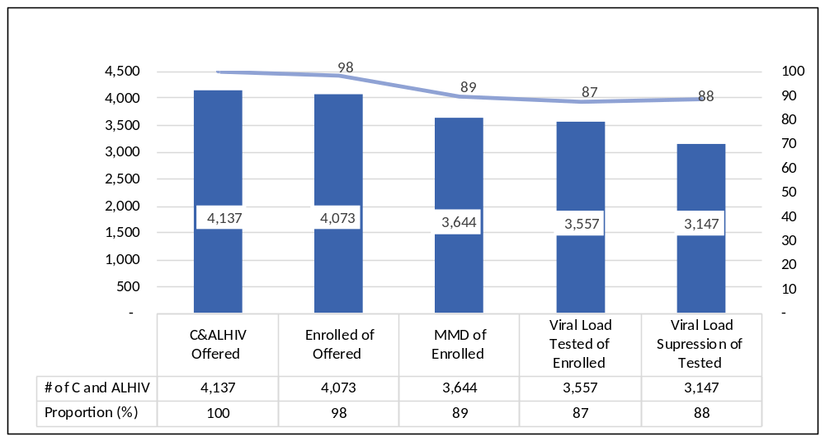

3.1.4 Facilitating Linkage to clinical, and socio-economic services
3.1.4.1 Improved and expanded access to comprehensive services for OVC

During this reporting period, 52,134 OVC (<18) reached with one or more services, based on individual needs and case plan implementation. This represents 98% achievement against the target of 53,326 OVC. Additionally, 26,495 caregivers were served directly and/or through referrals, as per their care plan, which is much higher than the targets for the FY. The caregivers that are enrolled in the program deviates from the target as this number depend on the number of enrolled OVC and households.
Therefore, during this reporting period, the total OVC beneficiaries benefited from FFHPCT activities with the comprehensive case management interventions were 78,629, 95% of all the enrolled 82,563 OVC and primary caregivers.
Among the packages of services, the main services these beneficiaries received include health, HIV (e.g., testing, VLS, adherence follow-up, LFTU, counseling), child safeguarding interventions (e.g., violence screening, creating access to packages of services to survivors of violence), school fee exemptions, free medical services, clothes, food items, and sanitary materials for COVID-19 prevention. Additionally, the 9-14 years old adolescents participated in time-limited, curriculum-based trainings to reduce risks to sexual violence and HIV.
In the reporting period, additionally, FFHPCTA served 2,960 (5.6%) 9-14 years old adolescents with time-limited curriculum-based trainings including IMpower, Sinovuyo and CBIM. Furthermore, 1,878 primary caregivers of 9-14 years old adolescents had received Sinovuyo parenting training. The overall purpose of the training is to equip caregivers on how to interact constructively with their children and on how to prevent their children from any form of abuse including sexual violence.
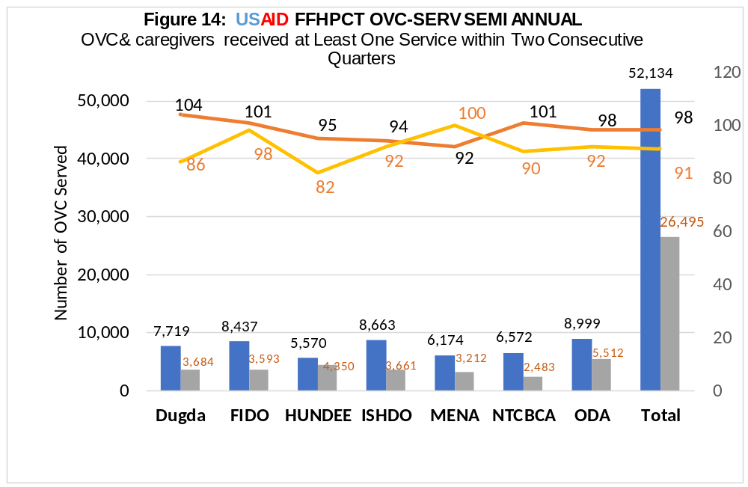
OVC-SERV performance varies across implementing partners – DUGDA,FIDO, and NTCBCA served all OVC they enrolled (100%) followed by ODA (98%) and Hundee (95%). It is worth noting that despite the unrest in some parts of the region, the FFHPCTA regional teams including LIPs staff and their community based workers made a concerted effort to achive this performance. The FFHPCTSA team had focused on fundational activities which were necessary for accerelated service provision.
3.1.4.2. Extended HIV/AIDS Services
During the quarter, 52,134 OVCs were served. With the different package of service listed above based on their need. Of these 43,840 (84.1%) are HIV negative, 2,44 (4.7%) did not require HIV test based on risk assessment, and 4,073 (7.8%) are HIV+. The OVC with unknown HIV status accounted for 1,773 (3.4%). Generally, 96.7 percent of active children had a known HIV status.

Figure 15: USAID FFHPCTA OVC Received HIV Services -HIVSTAT.

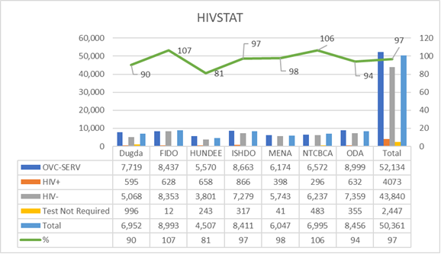
3.1.5 Engaging OVC beneficiaries into economic strengthening services
3.1.5.1. Household Economic Vulnerability assessment (HHEVA)
During this reporting period , FFHPCTA completed HHEVA for enrolled OVC households to assess and identify the level of economic vulnerability, in line with the National Economic Strengthning Guidelines. The HHEVA was completed for 26,549 OVC caregivers. From the completed assessment, preliminary results show that 47.3% caregivers are strugglers, 43.3% are destitute and lastly ready-to-grow are 9.4%. Figure 16 below illustrate this in detail.

Table 5: USAID FFHPCT HHEVA Result

IPs Name | DUGDA | FIDO | HUNDEE | MENA | NTCBCA | ODA | ISHDO | Total | %
Destitute | 924 | 1218 | 4346 | 1042 | 1503 | 1222 | 1241 | 11,496 | 43.3%
Struggler | 1813 | 2062 | 811 | 1662 | 1811 | 2467 | 1930 | 12,556 | 47.3%
Ready to Grow | 187 | 544 | 833 | 254 | 87 | 451 | 141 | 2497 | 9.4%
Grand Total | 2924 | 3824 | 5990 | 2958 | 3401 | 4140 | 3312 | 26549

During this reporting period, a total of 2,581 caregivers has benefited from household Economic Strengthening (ES) services – 2,212 (86%) from Savings groups, and 306 (12%) from social protection interventions including linkages to government’s cash transfers and direct asset transfers. During the 2nd quarter economic strengthening beneficiaries, those provided with Economic Strengthening services represent 56.7%.

FFHPCTA Asset Transfer intervention primarily targets destitute OVC households who are with high VLS and poor adherence and are not covered by any other government safety net or social protection schemes. In the reporting period, FFHPCTA provided asset transfers to 306 households to equip them with productive assets to help caregivers establish small enterprises. On average, the estimated value of asset provided was 2000-3000 ETB/USD $49-$73. From this scheme 545 C/ALHIV benefited.

3.1.5.2. VSLA establishment and support
During this reporting period, 850 VSLAs were established. The newly established VSLAs were provided with VSLA saving box, and trained in savings, loan management, record keeping, development of by-laws and other procedures for effective group management. The economic strengthening interventions have enabled caregivers establish small and micro-enterprises to cover the basic household necessities of food, schooling and medical expenses; and in the long run build their potential to become economically stable.
Most importantly, the likelihood of these interventions contributing to VLS and adherence of C/ALHIV and HIV+ caregivers is high and ISHDO is documenting and looking for evidences confirming the above .

Table 6. Economic Strengthening Interventions – Progress Towards Achieving Annual Targets

IPs Name | # of VSLAs | # of caregivers established VSLA | # of caregivers that received asset transfer | Total | CLHIV Received Asset Transfer
Dugda | 3 | 72 | - | 72 | -
FIDO | 29 | 688 | 25 | 713 | 63
HUNDEE | 31 | 636 | 75 | 711 | 75
ISHDO | 2 | 29 | 126 | 155 | 327
MENA | 40 | 40 | - | 40 | -
NTCBCA | 522 | 522 | 80 | 602 | 80
ODA | 225 | 225 | - | 225 | -
Total | 852 | 2,212 | 306 | 2,518 | 545

Sub IR 3.3: Improve primary prevention of sexual violence and HIV training and services for 9-14-year-old girls and boys.

The objective of the primary prevention intervention include: (1) to reduce risks of sexual violence among adolescent boys and girls aged 9-14 years and (2) reduce the risk of HIV among adolescent boys and girls aged 9-14 years. and (3) to build the capacity of parents to enable them to create a protective environment for their children. To meet these objectives initially FFHPCTA adopted IMpower and parenting for Lifelong Health (Sinovuyo) programs from the FHI360 Caring for Vulnerable Children (CVC) program.
These two curricula required certified workforce as a pre-requite to be cascaded with the 9-14 years adolescents. However, the training and certification of the workforce which was commenced in COP19 and disrupted by COVID-19 and is still in progress and will be extended to end of June 2021. This process is significantly affecting the effort of reaching FFHPCTA primary prevention beneficiaries and annual target.
Hence, Coaching Boys into men introduced in the program to complement the above two interventions through reaching the annual target and meeting unmet needs of 9-14 years old adolescents in terms of sexual violence and prevention from HIV.
The implementation status of these curricula described below

3.3.1 Parenting for Lifelong Health (Sinovuyo).
In the reporting period, 34 (100%) Sinovuyo facilitators have received the 3-days Sinovuyo Facilitators refresher training virtually by FHI360 in collaboration with CWBSA. Following the refresher training these facilitators continued their training with adolescents (9-14 years boys and girls) that was disrupted last year due to COVID-19 pandemic which is part of the training.
ISHDO in collaboration with FHI360 facilitated certification assessments of competency based on the training facilitation video which was the criteria for qualification to certify these facilitators. The assessors evaluated the proficiency of trained facilitators and provided recommendations for further development in order to meet appropriate competency thresholds to be a coach. According to this assessment, 30 (88%) of these facilitators met the minimum certification threshold (60%) and certified by master trainers of developers of the curriculum. Additionally, these certified facilitators received Sinovuyo Coaches training and progressed to the next level and became coaches.
Table 7: Sinovuyo Facilitators Certification and Coaching Training

IPs Name | Certification Facilitators | % Certified | Received Coaching Training | Grand Total | % Received Coaches Training
DUGDA | 5 | 83 | 5 | 6 | 83
ESSSWA | 1 | 100 | 1 | 1 | 100
FIDO | 8 | 100 | 8 | 8 | 100
HUNDEE | 3 | 100 | 3 | 3 | 100
ISHDO | 6 | 100 | 6 | 6 | 100
MENA | 2 | 67 | 2 | 3 | 67
NTBCA | 1 | 50 | 1 | 2 | 50
ODA | 4 | 100 | 4 | 4 | 100
Total | 30 | 88 | 30 | 34 | 88

    - Coaching Boys into Men /CBIM/
CBIM is one of the PEPFAR approved prevention curricula that ISHDO and ESSSWA adopted to complement other prevention curricula which are lagging on the implementation. Through USAID ISHDO AOR approval during this reporting period ISHDO and ESSSWA has been working the evidence based PEPFAR approved CBIM training curriculum and materials to adapt from Futures without Violence to the Ethiopian context and in way in which the curriculum addresses primary prevention program objectives of FFHPCTA. The adapted CBIM materials were translated from English into Amharic and Oromifa. The CBIM Card Series and monitoring, evaluation and reporting tools, implementation guide, and tools were disseminated to all implementing partners. Table 8 below shows the list of 9 different materials adapted, translated, reproduced and disseminated.
Table 8: Lists of CBIM training materials and tools.

CBIM Materials Adapted to Ethiopian Context, Translated, and Provided to IPs for Use During the Training and Implementation
- IMpower GESD Instructor's Curriculum
- CBIM Implementation Guide
- Sample school mini-media script
- Adolescent pre-season and pos-season assessment
- Coaches pre-season and pos-season assessment
- Adolescent attendance sheet
- Host a fan pledge day-Fan pledge day announcer script and pledge forms
- CBIM data collection and reporting templet
- CBIM supervisor’s checklist

During the second quarter, FFHPCTA launched the CBIM HIV and sexual violence prevention curriculum. This has been successful so far, with the following inception activities accomplished: reproduction of manuals and facilitator guides, tools and monitoring, evaluation and reporting frameworks; translation of materials; and printing of training material in utmost quality. These activities were followed by the selection of physical education teachers, who will be trainers of the curriculum from 16 OVC SNUs primary schools in collaboration with woreda education offices.

Additionally, FFHPCTA provided a 3-day training to a total of 276 physical education teachers on CBIM training curriculum, M&E tools and training implementation guidelines.
The ISHDO OVC technical expert team that led to the adaptation of the curriculum led the training. ESSSWA has covered the training costs of the training. This training was conducted from February 10-12,2021 at Adama town. Trained teachers now have the knowledge, skills and facilitation knowledge to cascade the training to 9-14 years old adolescent boys.
These trained teachers are currently delivering CBIM training to adolescent boys using sport as a platform in their respective schools.
ISHDO envisaged to reach 18,664 adolescent boys using 2-cycles with this complementary intervention of IMpower and Sinovuyo teens and CBIM coverage of 34,661 adolescent boys.

3.3.3. IMpower TOIs 2-Weeks Certification and Preparation Training

ISHDO worked with FHI360 to deliver a two-weeks instructors training certification and preparation training workshop for 11 female candidate trainers of instructors (TOIs). The training covered areas such as IMpower fundamentals, verbal skills, physical skills, weapons and multiple attackers, the Network Referral System, and Survivors in Recovery Anonymous. After the 2 weeks classroom sessions, the Global Master Trainers certified all the 11 ISHDO instructors as IMpower TOIs using scores of TOIs Assessment and 6-weeks practicum period feedbacks. The 11 trained instructors that completed 2 weeks training commenced the three weeks 3 weeks instructors training with candidate instructors who will facilitate IMpower curriculum with 9-14 years old adolescent girls.

3.3.4. Adolescents Served using time-limited curriculum-based trainings

In the reporting period, FFHPCTA reached 2,960 (5.6%) adolescent girls, boys and care givers using the exiting workforce including certified Sinovuyo facilitators, Impower TOIs ,physical education teachers of primary education. The Sinovuyo facilitators and TOIs have trained these children when they did their practicum with adolescents as part of their training. Of those reached through, 619 girls completed eight mandatory sessions to qualify as IMpower; 1,878 (1,084 female,794 male) adolescents completed Sinovuyo interventions and 463 boys received CBIM.

During this time, trained physical teachers are delivering CBIM curriculum to beneficiaries, adolescent boys. FFHPCTA planned to reach majority of adolescents with CBIM.

Table 9: USAID FFHPCTA IMpower, Sinovuyo and CBIM trainings to 9-14 adolescents

IPs Name | Sinovuyo |  |  |  |  | Total | IMpower | CBIM
IPs Name | Adolescents 9-14 yrs. |  | Total | Care givers (15+) |  | Total | 9-14 yrs | 9-14 yrs
IPs Name | F | M | Total | F | M | Total | F | M
DUGDA | 135 | 125 | 260 | 252 | 8 | 260 | - | -
FIDO | 237 | 83 | 320 | 270 | 50 | 320 | 219 | 463
HUNDEE | 44 | 36 | 80 | 58 | 22 | 80 | - | -
ISHDO | 268 | 232 | 500 | 474 | 26 | 500 | 400 | -
MENA | 76 | 84 | 160 | 156 | 4 | 160 | - | -
NTCBCA | 182 | 136 | 318 | 304 | 10 | 314 | - | -
ODA | 142 | 98 | 240 | 231 | 9 | 240 | - | -
Total | 1,084 | 794 | 1,878 | 1,745 | 129 | 1,874 | 619 | 463

Result 2: Strengthened utilization of data to monitor service delivery and conduct quality improvement of program services:

2.1.1 Utilizing USAID Unified Data System (UUDS)
ISHDO has been closely working with Project Hope further expand and optimally utilize UUDS for routine program monitoring, case management, and quality improvement. Accordingly, ISHDO has identified focal person from each IPs responsible for the data entry, established location hierarchy of partners and completed all the preparation for smooth data entry into the commcare system. Through the established collaboration ISHDO M&E closely worked with PH to solve challenges faced during day-to-day implementation.
ISHDO has facilitated virtual trainings on UDS and commcare to all IPs to provide basic knowledge of the use of the system and its implementation.

2.1.1.1 Commcare cascading activities

Project Hope provided a One-day M&E functions training on Commcare for M&E experts at all LIPs including head office M&E and technical team members for 13 staffs (11 male, 2 female) at June 30, 2021. A half day training on basics of Commcare training was provided by FFHPCTA internal staff on June 5, 2021 for 46 newly recruited CEFs in Adama town
ISHDO M and E team has provided technical support on commcare utilization through site visit, email and phone communication. In the reporting period IPs have entered different project data into UDS,
Types of data | Entered into UDS
OVC_SERV | 76,656
HIV_STAT | 2,362
PREV | 27,833
ICT | 6,597
CAG | 778
LTFU | 1,493
Single registration | 1,678
Total | 117,397

In addition, challenges related to flitter mechanism, blank form, data cleaning on UDS were discussed with PH team and resolved in the reporting period. Subsequently, we shared all guidance related to the issues that received from PH to LIPs. Following these guidance, M and E team stared serious follow up to ensure the quality of data in UDS.
Through communication with PH team in the reporting period 6 new accounts created, 2 old accounts closed; moreover, 5 web access created to M and E team and technical staff.

2.1.2 Equipping and data management

ISHDO closely worked with PH to find out solutions for recurring Commcare related issues raised during FY21Q3. Based on the feedback given there are few revisions: test date inserted for Community based testing, self-testing and health facility testing and also for OVC_PREV, start and end date are inserted to CBIM, Sinovuyo and Impower. This simplifies few ambiguities on Commcare data analysis.
IR 2.2. Improve quality of community HIV services
2.2.1 Program quality assessment and improvement
ISHDO FFHPCT Activity received a Three-day Adapted Basic Quality Improvement training by Accelerated Support to advanced Local Partners (ASAP) from June 20-22, 2021. A total of 7 ISHDO prime & ISHDO-sub staffs (2 male & 5 female) staffs participated in the training. Following the training all LIPs including ISHDO prime established QI team, prepared TOR, conduct meeting regularly and begin implementing different QI projects. The QI/QM design follows the Plan Do study Act/PDSA cycle approach and there were a total of 8 QI projects being implemented. Few of the QI projects were: Improving Data Quality, improving CAG & PCAD group formation, improving C&ALHIV enrollment, increasing case findings/yields and increasing Viral Load Testing. There are about 3 QI project in increasing CAG & PCAD group formation as this was the major under performance identified during the reporting period.

2.2.2 Conduct routine data quality assessments
Besides the JISS provided by ISHDO Family Focused HIV Prevention Care & Treatment/ FFHPCT Activity, the M&E team conducted RDQA for 3 LIPs (ISHDO-sub, DUGDA, MENA) in 1SNUs (Batu, Shashemene, Assela, Adama, , Bishoftu, Sebeta, Woliso, Burayu, Dukem, , Goba and Meki). RDQA action plan provided and implementation followed continuously. Documentation was emphasized during the RDQA visit and LIPs are technically supported to prepare a file folder for JISS, RDQA and Performance Review Meetings

2.2.3 Collaboration Learning & Adaptation
ISHDO FFHPCT Activity conducted Semi-Annual Performance Review Meeting in April 2021. As part of the review meeting best practices of selected LIPs were presented and lessons were shared to the remaining ones. This internal cross fertilization of best practices was a good scenario to initiate other LIPs to document their success and encouraged to share for others. ISHDO FFHPCT Activity required a minimum of 1 best practice for each LIP to share as part of the quarterly report and hence LIPs gave due attention to its documentation.

4. Monitoring, Evaluation and Reporting
4.1 Joint Supportive Supervision and Technical Assistance
4.1.1. Joint Supportive supervision:
ISHDO FFHPCT Activity prepared Joint Integrated Supportive Supervision checklist jointly with cluster office staffs. The JISS checklist is pilot tested during the supervision period. Internal Joint Integrated Supportive Supervision was conducted from May 11- June 4, 2021 by ISHDO head office and cluster office team in selected twenty SNUs (Batu, Shashemene, Assela, Adama, Adama zuria, Bishoftu, Sebeta, Woliso, Burayu, Dukem, Jimma, Nekemte, Metu, Robe, Adola, Shakiso, Goba, Meki and Boset). The purpose of the supervision is to review all programmatic activities using standardized supportive supervision checklist. This Joint Integrated Supportive Supervision set a baseline for the selected SNUs using dashboards. Moreover, the JISS checklist were revised based on findings from the field visit. For the next visit, the dashboard will be updated accordingly and progress will be documented. The team has provided on site oral and written feedback on gaps observed and recommendations: Use of proper and standard M&E tools, conduct RDQA regularly, positive verification before reporting & regular reporting to Town Health Offices.
4.1.2. Technical Assistance by ISHDO team to partners
4.1.3. Performance Review Meeting

ISHDO FFHPCTA conducted it`s first Performance Review Meeting from February 3 to 4, 2021 in Addis Ababa and there were 52 participants from all sub-partners and ISHDO team. FY 21 Q I Performance Review Meeting has a purpose to review key project achievements, areas of improvement, challenges on implementation and planning for the next quarter. Generally, as it was the first quarter of implementation most achievements were below the target except OVC enrollment for Children and care givers that meets the given target for the quarter, most TOT trainings were given to ISHDO prime & sub-partners, 36 smart phones were distributed to each sub-partner, successful deployment and use of Commcare were the key achievements besides many FFHPCT launching activities. Moreover, the review meeting helps to discuss in detail what were implementation challenges at each SNU. On the second day, planning discussion held thoroughly and that was a good opportunity to share ideas how to implement FFPHCTA in FY 21 Quarter II considering the discussion we had on our past performance & challenges encountered.
5. Grants and Subaward Management:
5.1 Implementing partners Risk Assessment:

Implementing partners risk assessment has been conducted to determine the risk level and gaps in finance, compliance and operations. The Grants team has conducted the assessment using a standard risk assessment tool that covers financial management, accounting recording, procurement, internal control and USAID grant management experience. Implementing partners policy and manuals have been also reviewed to ensure compliance and meets the minimum requirement for USAID Standard provisions.
The risk assessment was also used to develop special award conditions to address the gaps identified and mitigate the potentials risk associated with the weakness observed during the assessment.
5.2 Financial Report and Advance Transfer:
The Grants team reviewed Implementing Partners monthly financial reports and supporting documentation and verify that costs reported by Subrecipients are in line with USAID cost principles and project costs are allowable, reasonable and allocable. The Subaward expenditure and advances has been tracked through ISHDO finance system. Implementing Partners have also received their advance request by maintaining thirty days advance is available for uninterrupted project implementation and they will receive the consecutive month advance before the beginning of the reporting month.
5. 3 Subaward Monitoring:
Standard Subrecipients monitoring plan was developed based on the risk assessment. Routine and targeted supportive supervision by Grants teams was provided to IPs in utilization of funds as planned and in line with program interventions.
The Subaward management focused in strengthening ISHDO’s Subaward monitoring and technical assistance through subaward site visits and subaward financial report review and follow up to enforce compliance with USAID standard Provisions.
Accordingly, periodic monitoring and supportive supervisions were conducted to assess the financial management, record keeping and procurement, human resource by reviewing transactions of different types from previous Financial Reports.
ISHDO Grants team made proper follow up to ensure corrective actions have been taken by IPs and gave the required technical assistance in implementing the corrective measures.

7. Challenges, Constraints and plans to overcome them reporting period
7.1 Quarterly challenges and Constraints for each program area
Community HIV Care and Treatment
Case finding through ICT
- Low testing positivity for clients recruited from community
- High volume but low HIV positivity for children
- Low overall testing volume
Case finding through HIVST
- Low utilization of HIV self-test kits.
Geographic Hotspots
- Low testing volume in known geographic hotspots like Adola
Ensuring adherence of ART clients
- Limited tracing and identification of LTFU
- Collaboration with faith-based organizations not started
- Implementation of case management in CHCT only SNUs not started
Implementation of community-based differentiated care model
- Low uptake on establisment of CAG
OVC comprehensive care
- Poor integration of the CHCT and OVC services activities due to low capacity by Social service workers and caseworkers.
- Limited resources in the community to address unmet needs of beneficiaries:
- COVID-19 pandemic:
- Political unrest:
7.2 Plans to Overcome challenges
Community HIV Care and Treatment
Case finding on ICT

Training and on Job coaching to CEFs and volunteers on the correct use of risk assessment that prioritizes testing of children of newly diagnosed parents and sexual partners of index cases having with high viral load

Establishment of testing corner for CEFs that is private and confidential
- Improving collaboration with OVC workforce to identify eligible contacts in OVC households by training Care and support officers and SSWs
Case finding through HIVST
- Maximizing utilization of self test kits especially during outreach testing by focusing on refusals
Geographic identification of Hotspots

Provide special support for known hotspots by like Adola by accelerating identification of known HIV+ FSWs and tracing their sexual contacts
Ensuring adherence of ART clients
    - Maximize the engagement of PLHIV association and faith-based organizations in tracing of LTFU cases from Churches and worshiping places

Increase collaboration with SSWs and OVC case workers in tracing of LTFU cases by increasing geographic coverage
    - Establish clear baseline of LTFU cases for the quarter and track performance accordingly
    - Implement CHCT case management in CHCT sites to promote adherence among CLHIV, newly diagnosed cases, and PLHIV with High Viral Load

Implementation of community-based differentiated care model
- Intesify the cascading of training to health care workers, HEWs, and peer ledears
- Establish regional TWG to implement community DSDM models and ensuring involvement and endorsment of ORHB.

Comprehensive OVC Services and Measures Taken to Address Them
- Provide trainings to staffs on CHCT and OVC for betetr underaatnding of programs and integaration and coordination.
- Coordinate the activity is collaboration with CCCs, community and health facility to enhance accessibility of services to beneficiaries.
- Utilize COVID protection and mitigation measures and ensure service delivery continues maintaining COID prevention measures ,keeping physical distances and wearing mask. frequency of home visits by case workers.
- limiting travel out of SNU and start delivering service by intown staffs and volunteers

8. Data Quality issues during the reporting period

Data Quality issues and how they were addressed during the reporting period

During the reporting period, data quality issues were observed in the process of case management and CHCT activities. Among the data quality issues observed, the major quality issues are list below:
- All index contacts in line list received from health facility not entered to Commcare
- Index case contact line list received incomplete to document and to trace the clients
- Clients tested at community by conventional testing not documented on conventional testing register and they were only documented on tracking register
- Feedbacks from health facility not received on time
- Discrepancy occurred between ICT line list received, tracking register documentation, Commcare data entry and source document
- There was no line list for CRP, conventional testing register, HIVST register, referral service register
- Updated format not available in hard copy except soft copy at M&E level
- Reports not shared to Zonal / Woreda health office even if they perform conventional test
- SNU M&E well not organized, data not analyzed, reviewed, and used at lower level
- Data were not verified and reviewed before sending to the next level
- All case management data not entered into Commcare
- Blank values in reported services
- Incomplete data in submission of Case Management process
- In appropriate sub population categorization
- Delay in reporting
What you are doing on a routine basis to ensure that your data is high quality for each program area?
- FFHPCTA provided orientation and continuous communication with IPs regarding gaps and errors and sharing recommendations and instructions for improvement. Moreover, ISHDO technical staff jointly worked on the data quality issues and address accordingly.
In addition, technical staff follows up with each IP and provide technical assistance to ensure that the gaps are addressed and records are updated.
- The M& E team continued to provide reminders to IPs and ISHDO technical staffs ensure that appropriate data collection forms, including referral forms, are used and completed accurately. The staff continues to monitor progress and to provide assistance during monitoring and supportive supervision visits.
How you planned to address those concerns / improve the quality of your data for each program area
- M & E team has prepared and shared data verification tool to avoid/minimize data quality issues during implementation of acceleration plan; conducted data verification via desk review, specifically looking at enrolment and HIV STAT database of the activity. Feedback was provided to IPs on the corrective actions to improve the data quality. FFHPCTA will undertake field visits to supervise, coach and mentor the M &E team on data quality and routine data quality assessment will also be rolled out during this time.

9. Major Activities planned in the next reporting period

Result 1
Community HIV care and treatment
Trainings will be provided for CEFs, case workers, and technical staff:
- Training on ICT, and HIV Self-Test for newly deployed CEFs
- Training on Recency Testing once EPHI aproves community level implementation
- Training on CHCT Case management in CHCT SNUs
- Training on Differentiated Serice Delivery Models in health facilities not already covered
- Training for care and support officers and SSWs about CHCT activities inclusing ICT, LTFU tracing and CAG/PCAD member recruitment as well as cervical cancer screening
- Establishment of monthly forums with IRC and NNAPWE to coordinate care and support activities
Comprehensive OVC programming
- Preventing, recognizing and reporting child abuse (sexual, physical, emotional) using child abuse response protocol
- Provide a 4-days training to CCCs on quality care, data quality management and reporting.
- Train LIPs on Micro Enterprises -Selection, Planning and Management (ME-SPM) & Business Development support (BDS)
- Adapt/develop tools and standards to assist the screening of GBV among adolescents and caregivers.
- Prioritize enrolling new HIV+ children as well as boys and girls aged 9-14 years.
- Adapt CCCs capacity assessment tool and capacity plan template.
Primary Prevention to 9-14 Adolescents
- Cascading sexual violence and HIV prevention trainings (e.g., CBIM and IMpower) to 9-14 years old adolescents.
- Train IMpower Instructors to deliver the training to adolescent girls (9-14 years)
- Analyzing pre-post assessments of CBIM and IMpower trainees to generate evidence.
Result 2
- Ongoing Supportive supervision, review meetings and RDQA
- Ensure the better functionality of commcare application in collaboration with PH

10. Environmental compliance
Describe any issues related to environmental compliance (if there are any)
During FY21, SAPR, FFHPCTA has implemented safety standard for HIV related services through community-based HIV testing to comply with the Ethiopian government and USAID environmental policy. Safety boxes and biohazard bags were used at to collect used lancets, cotton swabs and disposed for incineration at adjacent health facilities.

11. Financial accomplishment

(… in USD)
Life of Activity budget  (a) | Obligated  to date  (b) | Expenditure  (Accrual and actual disbursement)  to date  (c) | Remaining balance  (d) = (b) – (c) | Remarks
9,948,804.00 | 3,316,268.00 | 1,047,623.86 | 2,268,644.14

12. Issues requiring the attention of USAID Management
- Constant supply of HIV test kits including HIVST, recency testing kits to ensure continuous community testing by the community partners.
- Ensure commcare and UDS capture all the needed variables on HIV testing (ICT) and other services to avoid parallel data collection by Prime partners
- Maintain adequate and continuous budget flow to maintain continuity of activities in the IPs.

13. Data Sharing with Host Government:

Have you shared this report with the host government?

Yes
No

If yes, to which governmental office/s?

- Regional Health Bureau

If No, why not?

[Please put your response here]

Have you made data reconciliation with respective regional sectoral office/s?

Yes
No

If yes, to which regional sectoral office/s? Were there any issues that came out from the reconciliation? How these issues were handled/ will be handled?

There is no need for data reconciliation as our sub partners are responsible to do. ISHDO as prime didn’t sign agreement with respective signatories. Only MOU are expected to be signed with major stakeholders which is RHB.

If no reconciliation was made, what are the reasons for it?

[Please put your response here]

14. Appendices

