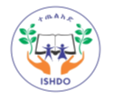
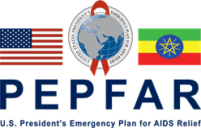
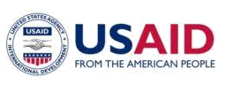


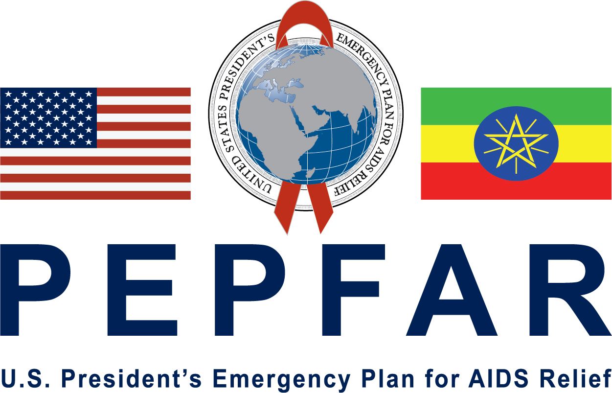
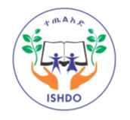
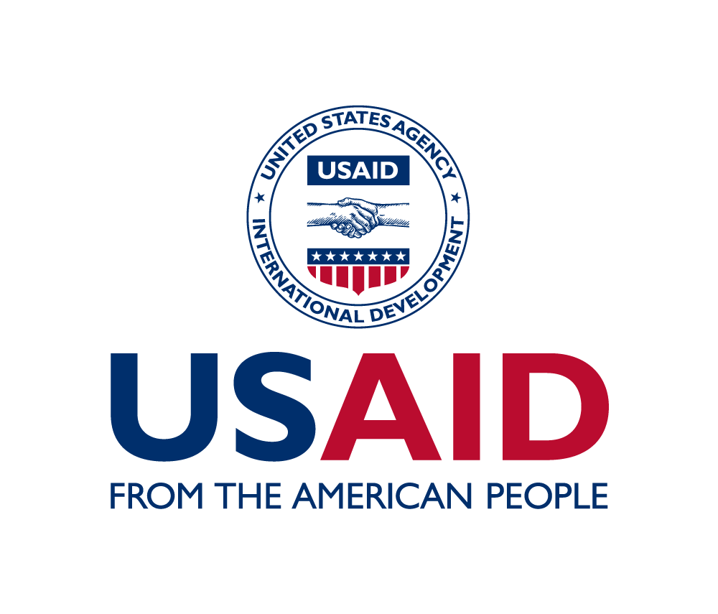

USAID/PEPFAR Ethiopia In-Country Reporting System (IRS)
Reporting Template

Integrated Service on Health and Development Organization (ISHDO)

program results
for

Fiscal Year 2021,
third QUARTER PROGRESS REPORT

(april 1,2020 to june 30, 2021)

CONTACT INFO FOR THIS REPORT:

Dr Girmachew Mamo
Chief of Party
+251911226097

LIST OF ACRONYMS

APC
Area Program coordinator
ART | Anti-Retroviral Therapy
C/ALHIV | Children and Adolescents living with HIV
CAG | Community ART Refill Groups
CEF | Community Engagement Facilitator
COP | Chief of Party
CWs | Case Workers
FFHPCT | Family Focused HIV Prevention, Care and Treatment
FIDO | Fayyaa Integrated Development Organization
HF | Health Facility
HIV | Human Immune Virus
ICT | Index Case testing
ISHDO | Integrated Service on Health and Development Organization
LIP | Local Implementing Partners
LTFU | Loss to Follow Up
MENA | Mekdim Ethiopia National Association
MMD | Multi Month Dispensing
MOU | Memorandum of Understanding
NTCBCO | Nekempt Charity based community Organization
ODA | Oromia Development Association
OVC | Orphan and Vulnerable Children
PEPFAR | President’s Emergency Program for AIDS Relief
PLHA | People Living with HIV AIDS
SNUs | Sub National Units
SSWs | Social Service Workers
TOI | Trainers of Instructors
USAID | United states Agency for International Development
VL | Viral Load
VLS | Viral Load Suppression

TABLE OF CONTENTS

1. Reporting period 4
2. Publications/reports 4
3. Technical assistance 4
4. Travel and Visits 4
5. Activity 5
6. Accomplishments and successes during the reporting period 16
7. Challenges, Constraints and plans to overcome them during the reporting period…...18
8. Data Quality issues during the reporting period 23
9. Major Activities planned in the next reporting period 24
10. Environmental compliance 26
11. Financial accomplishment…………………………………………………………...26
11. Issues requiring the attention of USAID Management 26
12. Data Sharing with Host Government: 26
13. Appendices 27

1. Reporting period

From April 1,2021 | To June 30,2021

2. Publications/reports
Did your organization support the production of publications, reports, guidelines or assessments during the reporting period?

No/Not Applicable
Yes If yes, please list below:
Publications/Reports/Assessments/Curriculums
Title | Author | Date

If Yes, please attach an electronic copy of each document as part of your submission.

3. Technical assistance
Did your organization utilize short-term technical assistance during the reporting period?
No/Not Applicable
Yes Please list below:

Consultants/TDYers
Name | Arrival | Departure | Organization | Type of Technical assistance provided

If Yes, Please attach an electronic copy of the TA report as part of your submission.

4. Travel and Visits
Did your organization support international travel during the reporting period?

No/Not Applicable
Yes Please list below:
International Travel (All international travel to conference, workshops, trainings, HQ or meetings).
Name | Destination | Departure from Ethiopia | Arrival | Host Organization | Purpose of the travel

Have any Monitoring Visit/supervision been made to your program in during the reporting period?

Description of Monitoring team | Start date | End date | Sites visited | Written recommendations provided
USAID Activity Manager | April 10, 2021 | April 12, 2021 | Boset | Yes
USAID Activity Manager | April 13, 2021 | April 14, 2021 | Assela |  | Yes
ISHDO HIV Specialist & Adama cluster office Project Coordinator | April 19, 2021 | April 20, 2021 | Boset |  | Yes
ISHDO HIV Specialist & Adama cluster office Project Coordinator | April 20, 2021 | April 21, 2021 | Adama Zuria |  | Yes
ISHDO prime C&S Specialist, M&E Specialist, ISHDO-sub PC & ES Specialist | May 16, 2021 | May 29, 2021 | Sebeta, Burayu, Ambo, Becho, Dendi, Fitch, Kuyu and Sululuta |  | Yes
ISHDO OVC Specialist & M&E Director | May 17, 2021 | May 20, 2021 | Adama |  | Yes
Project Hope | May 21, 2021 | May 24, 2021 | Adama |  | Yes
Ambo Clusters Program Coordinator | May 24,2021 | May 26 ,2021 | Nekempt |  | Yes
Adama Clusters HIV Service Officer | May 24,2021 | May 26 ,2021 | Nekempt and Gimbi |  | Yes
ISHDO M&E Specialist, Adama cluster HIV Specialist and OVC Specialist | May 24,2021 | June 4,2021 | Shashemene, Goba, Dodola, Ginir, Bale Robe and Bulehora |  | Yes
ISHDO M&E Director, OVC Specialist, HIV Specialist | May 24,2021 | May 28,2021 | Assela ,Batu, Meki |  | Yes
Ambo cluster PC, OVC Specialist, HIV Specialist | May 24,2021 | May 28,2021 | Nekempt Jimma and Metu |  | Yes
ISHDO C&E Specialist & Ambo cluster PC | May 24, 2021 | May 28,2021 | Bishoftu, Adama and Mojo |  | Yes
ISHDO sub HIV Specialist | May 25,2021 | May 31,2021 | Sululta, Fitche, Kuyu, Holeta, Adaberga, Jeldu, Dendi and Becho |  | Yes
ISHDO HIV specialist, OVC Specialist & M&E Director | May 25, 2021 | May 26, 2021 | Boset |  | Yes
ISHDO HIV Specialist, OVC Specialist & M&E Director | May 27, 2021 | May 28, 2021 | Assela |  | Yes
ISHDO OVC Specialist & M&E Director | May 29, 2021 | May 29, 2021 | Assela |  | Yes
ISHDO M&E Specialist | May 28, 2021 | May 28, 2021 | Bale Robe |  | Yes
Project Hope | June 10, 2021 | June 11, 2021 | Assela |  | Yes
Adama cluster office Project Coordinator | June 17, 2021 | June 18, 2021 | Chiro |  | Yes
OVC Service Specialist, Project Coordinator | June 24,2021 | June 30,2021 | Wolliso, Sebeta, Adaberga, Holeta, Burayu and Wolso |  | Yes
ISHDO prime C&S Specialist, M&E Specialist, ISHDO-sub PC & ES Specialist | June 1, 2021 | June 15, 2021 | Ambo, Woliso, Jeldu, Adaberga and Holeta |  | Yes
ISHDO HIV Specialist | June 07, 2021 | June 08, 2021 | Adama |  | Yes

5. Activity
Program Area  (Tick all which apply) | Activity ID | Activity Title (Please write the title of the activity)
01-PMTCT
02-HVAB
03-HVOP | 72066320CA00013 | Family focused HIV prevention, care and treatment activity in Oromia
04-HMBL
05-HMIN
07-CIRC
08-HBHC
09-HTXS
10-HVTB
11-HKID
12-HVCT | 72066320CA00013 | Family focused HIV prevention, care and treatment activity in Oromia
13-PDTX
14-PDCS
15-HTXD
16-HLAB
17-HVSI
18-OHSS

6. Accomplishments and successes during the reporting period

Project Overview
Family focused HIV, prevention, care and treatment activity is a USAID funded activity Implemented by ISHDO and its partners in Oromia region for the period of Oct 2020 to September 2023 with a total budget of USD$ 9,828,785 million.

The main purpose of the activity is to strengthen HIV epidemic control so that 95% of individuals living with HIV know their status, 95% of persons living with HIV initiate antiretroviral therapy and 95 % of clients on antiretroviral therapy achieve viral load suppression by 2030.

This community HIV Care and Treatment activity aims to accelerate and sustain HIV epidemic control in Ethiopia through assisting delivery of high-impact community-based HIV services and support community-based case finding through ICT, tracing of LTFUs, HIV self-testing, provision of referral to HF for care and treatment services and support the establishment of community ART refill groups.
The project also implements a high quality OVC program that is aligned with new direction and priorities of PEPFAR OVC programs emphasizing on Comprehensive Case management and Primary Prevention of violence and HIV among 9-14-year girls and boys in line with PEPFAR technical Capacity domains for prime partners.

USAID family focused HIV prevention, care and treatment activity will support the implementation of Community HIV care and treatment services, comprehensive HIV service for OVC and primary prevention for adolescent aged 9-14 in 41 woredas/towns of Oromia National Regional State.
This project is implemented as prime by integrated service on Health and development Organization and 6 sub local implementing partners namely
1) MENA,
2) DUGDA,
3) ODA,
4) FIDO,
5) HUNDEE
6) NTCBCO and ISHDO in selected 41 woredas /towns of Oromia regional state towns and collaboration with major regional stakeholders’ Bureaus of Health, Education, Women Children and Youth, Labor and Social affairs and Finance and Economic Development.

Overview of FY21 QUARTER THREE

The third quarter is the continuation period for the acceleration of FFHPCT activities which lag in performances. Each partner has developed a catch-up plan to improve performances in achieving targets of major performance indicators.
ISHDO team collaborated with Project Hope to receive onsite technical assistance support one index case testing and case finding. Selected 10 sites have received a TA support by Project Hope team and additional 8 sites have received TA by ISHDO prime team and USAID activity manager.
ISHDO team collaborated with Oromia regional Health bureau and Project Hope to work and improve performances of Differentiated service delivery Models (DSDM) ,CAG ,PCAD.
Oromia Health Bureau provided guidance for CAG and PCAD models as option for community ART service delivery and assigned target.
ISHDO and PH in collaboration organized Orientation meeting to selected public sector coordination staffs and facilities with high burden service delivery sites to facilitate support and implementation of case finding and community ART.
Additional staffs that assist in case finding were recruited and received training on OVC CHCT integration, case management and commcare.
ISHDO team, based on the training provided by TA partners cascaded the training to partners, mostly in the second quarter but the remaining staffs who has not been reached in the second quarter.
ISHDO team has organized training on Psychosocial support, VSLA, community care coalition, case management to program staffs of IPs to support the implementation of activities and cascade of knowledge and skills to the caseworkers who has been doing the activity at community level. Accordingly, the IPs have also cascaded the training to their Volunteers (case workers) and the training was supervised by ISHDO as prime.
PH and FHI360 also organized a regular biweekly follow-up meeting to share experiences and understand gaps and give the necessary support as needed. ISHDO central team has also been following the IPs based on weekly reports and virtual meeting organized on bi weekly bases and program areas meetings (CHCT, OVC and M&E virtual meeting organized on weekly bases.
ISHDO Joint team has also conducted a joint integrated Supportive supervision in selected ISHDO and partners implementation towns using a structured checklist conducted verifications of data (CHCT/ICT data) and provided feedback for improvement in selected ……SNUs.
Semiannual performance review meeting was also conducted in quarter 3 with 50 key staffs of FFHPCT activity. The participants reviewed key performable indicator achievements and discussed over the challenges and possible solution and planned for the way forward and the third quarter.
ISHDO has devised and acceleration and catchup plan to track performances and conducted daily tracking of targets and weekly virtual review of performances and quarter review meeting in person to review performance and develop plan to improve performance in areas where major gaps are observed.

Accordingly, ISHDO and partners has provided and conducted HIV testing services through ICT and HIVST through community and facility-based modalities to intensify case finding and enrolled into treatment, Tracked LTFY and Established CAG and PGAD groups for refills.
ISHDO and partner has also additionally enrolled CALHIV, vulnerable children & families and enrolled into care reaching over 51,498 eligible children & families and provided need-based services .
The major Achievements in this period is as follows
FY2021, QAURTER 3, FFHPCTA key performance indicators
- Elicited 6032 contacts of index cases using line list collected from facilities and communities.
- Tested contacts of 5952 contacts of Index cases
- Identified 227 HIV positives cases from the contacts identified.
- 285 (26% of Q3 target) HIVST kits distributed to beneficiaries
- 3 HIV positives identified through HIVST.
- Identified 155 LTFU cases line listed from Health facilities,
- 119 (78%) were tracked and re-engaged,
- 13 CAG groups with 84 members were established and refilled.
- 142 PCAD groups having 809 members were established and refilled.
- 51,498 (98%) OVC enrolled into Comprehensive care received services .
- 25,158 caregivers who enrolled into care received services.
- 4,073(98.4%) children and adolescents living with HIV were enrolled into care.
- 12874 adolescent girls were reached on IMpower curriculum.
- 2354 adolescents and caregivers were reached through Sinovuyo curricula.
- 26346 Adolescent Boys were reached through Coaching Boys (CBIM) into Men curricula.

FY2021, QUARTER 3 FFHPCTA key achievements

Result 1: Increased access and demand to family-focused HIV services that reduce HIV
IR 1: HIV testing and counseling in the community
1.1 HIV case finding through ICT

ISHDO and its partners provided HIV testing services in the community and at health facilities in collaboration with public health facilities.
All forms of testing (both communities based and health facility) was done for 5952 children and adults and 227 HIV positive cases were identified.
Of 3438 index HIV+ cases, 6032 contacts were elicited of which 5959 were tracked and found. Of the elicited contacts 73 was not found. The remaining 5952 were tested for HIV. An average of 1.75 people was elicited per index case which is an improvement from 1.5 during the semi-annual period. The testing cascade is shown in Figure 1 below.
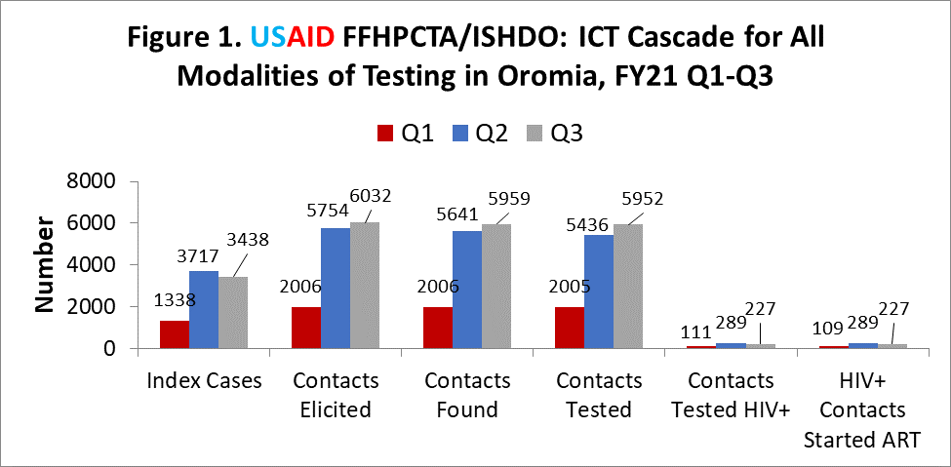

Community based ICT HIV testing was 5410 for the quarter which makes the cumulative testing 10,573, 51% of the 9-month target. Similarly, 192 HIV+ cases were identified (cumulative 358 for 9 months) making the progress at 11%. (Figure 2)

The overall testing volume especially for community-based test was low due to limited and delayed supply of test kits, accessories and supplies to do community-based testing. Establishing well-functioning relationship with health facilities also remains an ongoing challenge even though there are significant improvements in the number of line lists given from health facilities.

Despite the carious efforts is the short period to use innovative solutions for maximize yield and testing, testing yield continues to be low especially for clients recruited from the community at 3.3% compared to health facility-initiated ICT which is at 8.0%.

The attributing factor for low testing yield is the loose application of risk assessment tool by CEFs at community level. Focus on index testing for partners of index cases who are stable on ART and virally suppressed has been identified as the root cause for low testing yield. Coaching is being provided to CEFs in the use of appropriate risk assessment focusing to identify indexes with high viral load, poor adherence and newly diagnosed HIV+ cases before testing contacts.
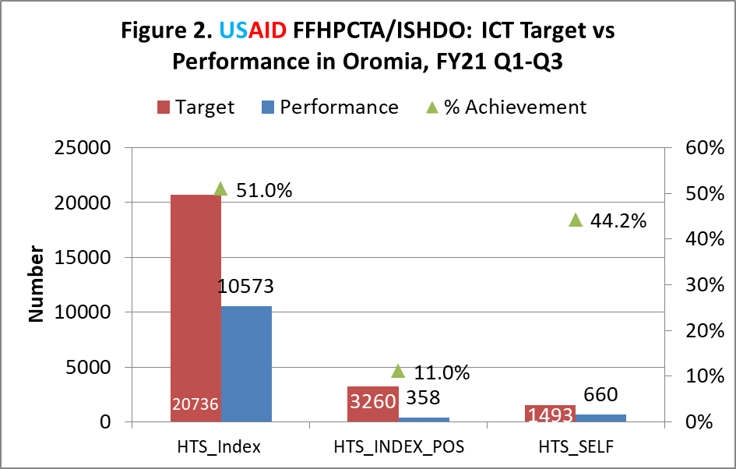

Additionally, testing yield also decreased for sexual partners (Figures 3 and 4) The use of partner notification services for all newly diagnosed HIV+ cases is being used to ensure testing yield remains high. The testing of children has reduced from 46% during Q1 to 25% during Q3 because of the focus of testing of children who were never tested for HIV.

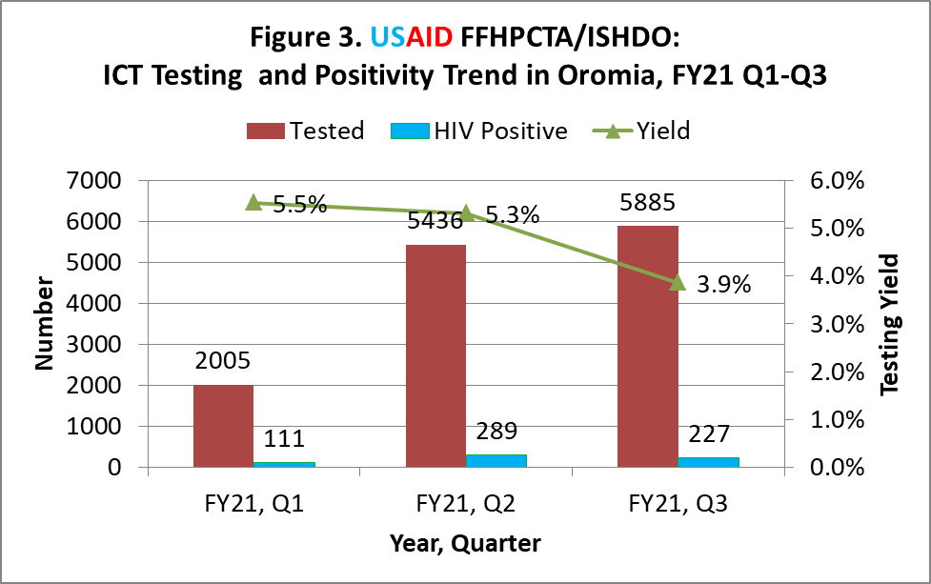
Testing increased slightly compared to Q2 because of implementation of accelerated case finding activity and deployment of new CEFs. However, testing yield decreased from 5.3% during Q2 to 3.9% during Q3 because IPs kept testing low risk contacts especially children with 1.5% yield.
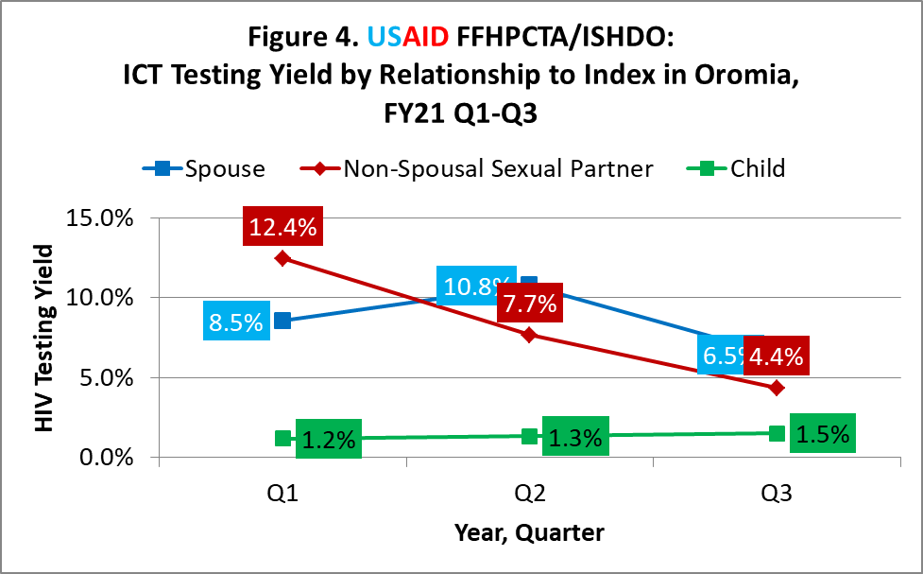
Fig 4. The ICT testing yield in quarter 3 for spousal and noy spousal partners has decreased significantly from quarter two. Spousal partners from 7.7 to 4.4 and nonspousal sexual partners from 10.8 to 6.5 and slight increase from 1.3 in Q2 to 1.5 among children.
This is attributed to testing of low risk contcats among sexual and non sexual partners and focsued testing among children

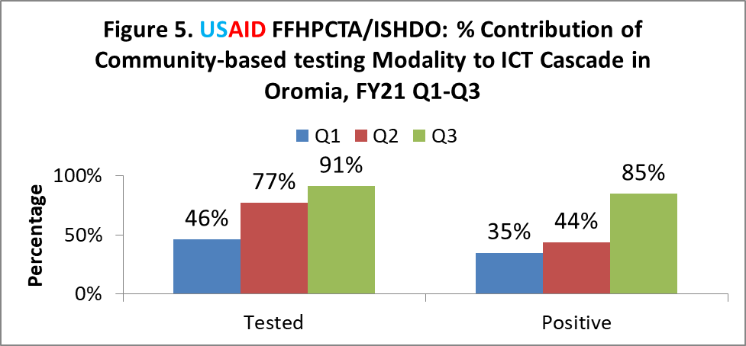

The relative contribution of the community based index case testing using rapid HIV test kits is shown in Figure 5. 77% ICT testing during Q2 was done through community based testing comared to 91% during Q3.

1.2 HIV case finding through HIV self-testing

HIV self-test is being used as an alternative for case finding in community-based setting. A total of 285 HIV Self tests were distributed during Q3.

This makes the total kits distributed so far in 9 months 660. 5 out of the 285 HIV self-test kits distributed during this reporting period were unassisted. Three HIV+ cases were identified using HIV self-test kits. All were confirmed with rapid tests.
The limited distribution of HIVST in assisted and not assisted is the limited stock of HIVST for distribution.

1.3 Active Linkage to Care and Treatment

Linkage to treatment for all 227 newly diagnosed HIV positive cases during Q3 were successful. All of them were linked and started ART at 100%. (Figure 1)

1.4 Geographic and demographic hot- spots identification
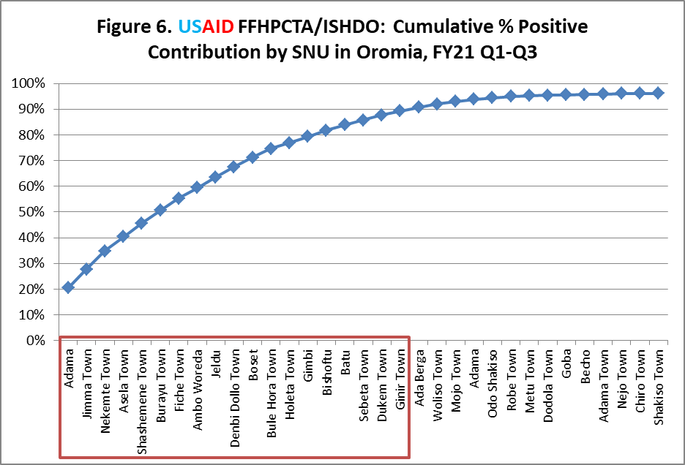
Only 19 SNUs contributed to
90% of HIV+ Cases Detected
Figure 6 below is a Pareto chart that shows the cumulative proportion of HIV+ cases newly diangosed by SNU. 19/33 SNUs that reported ICT testing, accounted for 90% of the new HIV+ cases diagnosed. Case finding will accelerate further during Q4 in these SNUs and we will make all SNUs functional in terms of contributing to ICT.
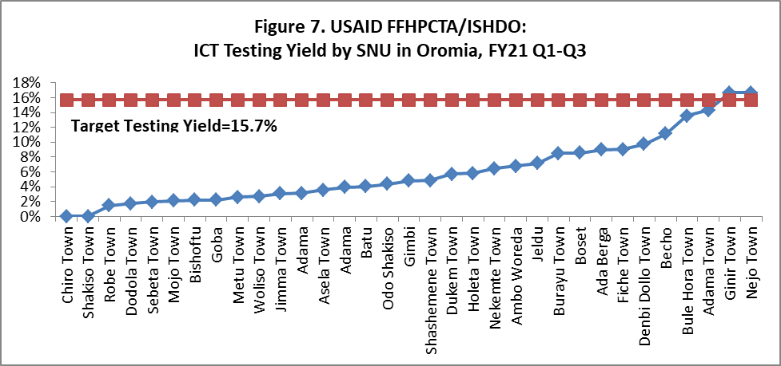

Figure 7 shows that ICT testing yield by SNU reaching >16% in only two SNUs (Figure 7). Strict implementation of risk assessment tools, use of PNS and avoiding testing of children with known status will be used to ensure higher testing yield in many SNUs during Q4.
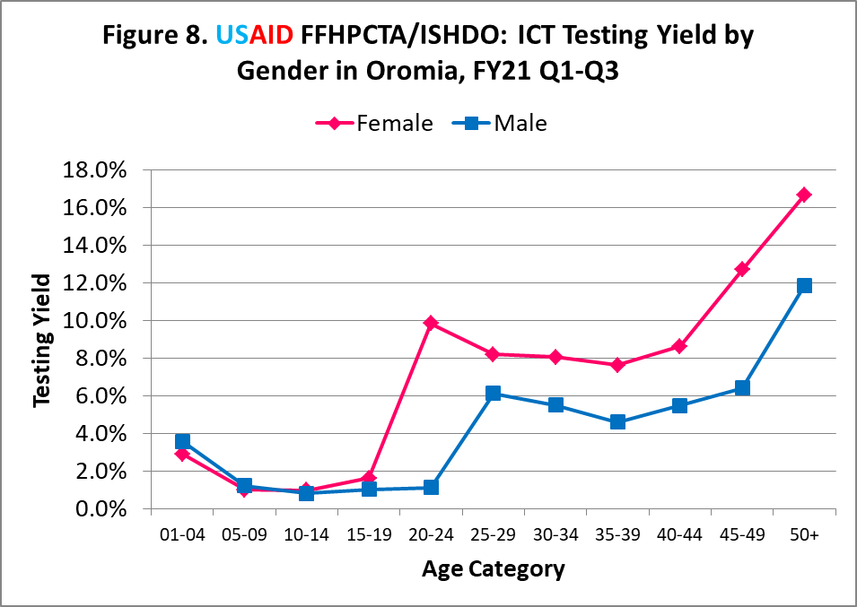
Testing yield by demographic factors is indicated for age and gender in Figure 8. Age and gender differences are seen clearly with women in the age groups 20+ and 40 + Men in the age group 50+ having the highest positivity rate.
FFHPCT will be focsueding on these age grpups to intensify casefinding during quarter 4

1.5 ICT and Case Management Trainings

During the reporitng period, CHCT-OVC Service integration training was provided to the OVC work force for care and support officers and social service workers in two rounds. Newly deployed CEFs were also provided with training on ICT/PNS, DSDM, and CHCT case management.
New CEFs were deployed because of shortage of work force espacially DSDM and case management services which were lagging behind in implementation

Table 1: List of Trainings cascaded under FFHPCT by ISHDO

Training Type | Training provider | Date of the training | Sex |  | Participants of sub partners
Training Type | Training provider | Date of the training | Male | Female | Participants of sub partners
CHCT-OVC Service Integration | ISHDO Prime | April 20-23, 2021 | 38 | 30 | DUGDA, HUNDEE, ISHDO and ODA, FIDO, NTCBCA
CHCT-OVC Service Integration | ISHDO Prime | May 17-20, 2021 | 19 | 16 | DUGDA, HUNDEE, ISHDO and ODA, MENA, FIDO, NTCBCA
ICT, CM basic training | ISHDO Prime | May 31-June 5, 2021 | 23 | 22 | DUGDA, HUNDEE, ISHDO and ODA, MENA, FIDO, NTCBCA

IR 2: Increased adherence and retention on ART through targeted community case management including adherence counseling and support, disclosure, and psychosocial services for PLHIV

2.1 Ensuring adherence of ART clients

During quarter three, Tracing of lost to follow-up (LTFU) cases was done incollboration with helath fcailoities . Out of the 155 linelists of contcats received for LFTU from health fcailities 119 (77%) were re-engaed to treatment through the community reintegartion services provided by IPs.
During 9 months of implementation, of 886 LTFU cases line listed, 689 (77.8%) were re-engaged, while 9 were found to be already on treatment, 10 were self transferred-out cases, while 16 were confirmed dead as shown in Figure 9 below..
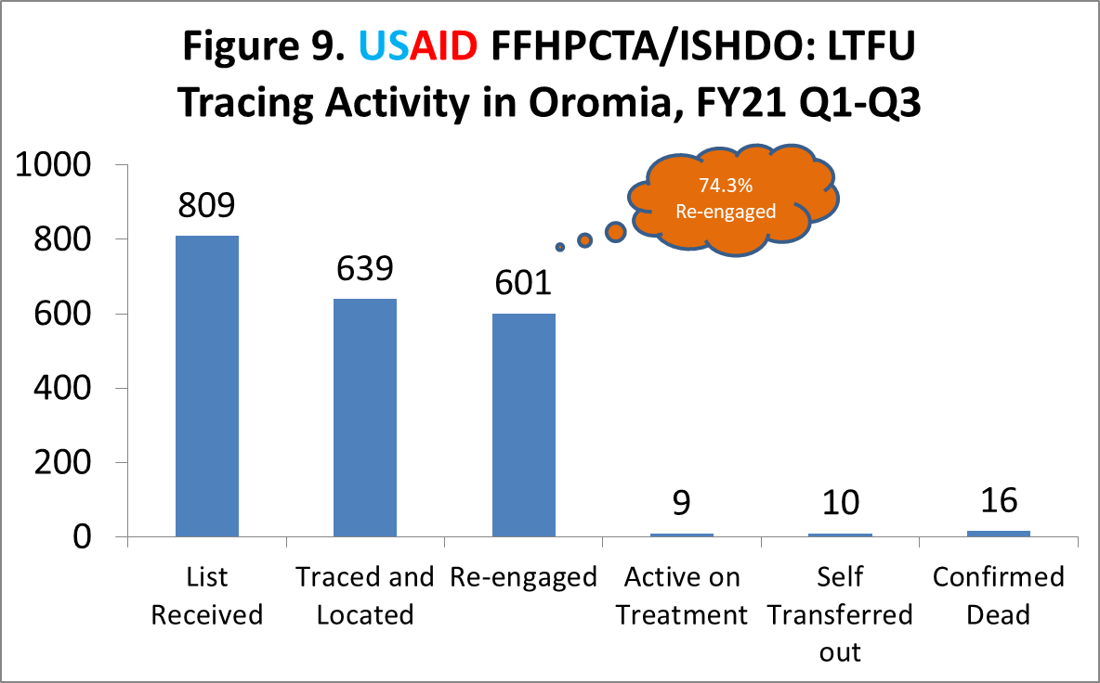

2.2 Strengthening bi-directional referral system

For LTFU cases who were traced and located, appropriate services were provided based on adherence barrier analysis conducted as to why they discontinued treatment. Figure 10 shows the burden of different adherence barriers identified.
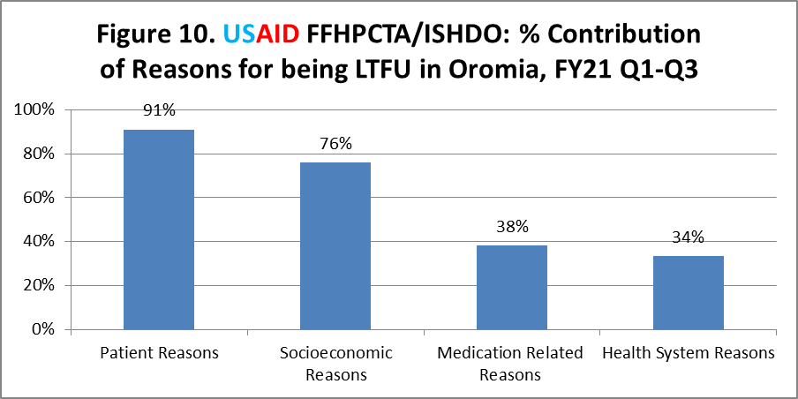

2.3 Demand creation for GBV and cervical cancer screening

A total of 289 at risk PLHIV were screened for gender-based violence of which 44 were found to have gender-based violence and were referred for legal and medical support.
Demand creation and screening for cervical cancer was also done for women with HIV. Accordingly, 656 women with HIV were reached with cervical cancer messages developed for this purpose through the caseworkers. During Q3 (1138 cumulative for 9 months). Of these, 201 received screening (717 cumulative for 9 months) and 5 were found to have cervical cancer (13 cumulative for 9 months).

Sub IR 2.1: Implement community-based differentiated care model, including healthcare worker managed groups and adherence peer led groups to improve adherence and retention on ART and achieve viral load suppression.

2.1.1 Implementation of community-based differentiated care model

These has been one of the major challenging areas of intervention for FFHPCT . Some improvement has been obsrved following the guidance by regional health bureaus to health facilities and health offices and repeated sensitization meetings on implementation done in collboration on this activity. The Regional Helath Bureau also assigned targets on community ART groups to selected high load ART facilities. As of Q3, 13 CAG groups having 84 members were established. In addition, 142 PCAD groups having 809 members were established. This is 21.7% of 684 CAG and PCAD groups expected to be established during the 9 month period.
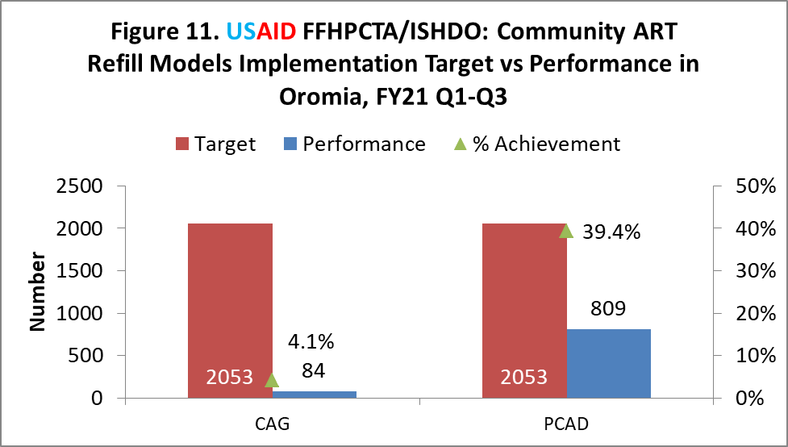

IR1.3 Increased access to high impact community-based services for OVC & HIV prevention

3.1 Implement Comprehensive OVC intervention
    - Support to Community Care Coalitions (CCCs).
During the reporting period, FFHPCTA continued strengthening the capacity of IPs to support CCCs in leveraging community resources for OVC households by providing technical assistance on micro-planning and resource mobilization strategy development and implementation.
As a result of these efforts, IPs supported 99 CCCs in the reporting period which raised cash and in-kind resources worth 3,231,833 Birr (US$ 76,043) in this reporting period. From the total resource mobilized with in the quarter 2,159,355 Birr ($50,081) was utilized to support OVC and caregivers enrolled in FFHPCTA. The resources raised were used to benefit more than 11,345 OVC and 4,936 caregivers enrolled in the FFHPCTA program with services.
These resources are mobilized from the 16 OVC SNUs from government, community support groups (e.g., Iddirs), private business owners, schools, religious institutions and NGO including establishing VSLAs, cash transfer schemes, free medical services, clothes, and food items.

Table 2: Resources Mobilized by CCCs to support OVC households in FY21, Q3

S/N | IPs Name | Resources Mobilized (Eth Birr)
S/N | IPs Name | In-Cash | In-kind | Total
1 | Dugda | 32,500 | 155,300 | 187,800
2 | FIDO | 190,750 | 800,170 | 990,920
3 | HUNDEE | 145,273 | 296,000 | 441,273
4 | ISHDO | 14,040 | 133,000 | 147,040
5 | MENA | 18,000 | 189,750 | 207,750
6 | NTCBCA | 234,930 | 342,490 | 577,420
7 | ODA | 5,000 | 674,630 | 679,630
 | Total | 640,493 | 2,591,340 | 3,231,833

3.1.2. Capacity Building trainings to Community care coalitions
During this reporting period, ISHDO organized and delivered training to 53 representatives (90.6%) of woreda health, social affairs and women children and youth offices who are members of the community care coalitions. They have trained on Oromia Region CCCs guidelines, procedures, standards and tools. These sector offices representatives developed woreda/SNU level micro-plans to cascade CCCs guidelines training to CCCs members and government sector offices to strengthen resources mobilization and referral linkages to vulnerable communities including HIV+ OVC and HIV+ caregivers. The training is initiated based on individual CCCs needs and capacity gaps, the most common areas are: resource mobilization, development of service directories and building partnerships with service providers through formalized MoUs.
Table 3: CCCs capacity building training for HIV Services, FY21, Q3

IPs Name | IPs Staff | Health Office | Woman Children & Youth | Labor and Social Affairs | Total
DUGDA | 1 | 3 | 3 | 3 | 10
FIDO | 0 | 2 | 2 | 2 | 6
HUNDEE | 1 | 2 | 2 | 2 | 7
ISHDO | 0 | 4 | 4 | 4 | 12
MENA | 1 | 1 | 1 | 1 | 4
NTCBCA | 1 | 1 | 1 | 1 | 4
ODA | 1 | 3 | 3 | 3 | 10
Total | 5 | 16 | 16 | 16 | 53

    - Enhance the capacity of community workforce

During the reporting period, all SSWs and CWs were receiving technical support and guidance during regular weekly meetings organized by IPs offices as per the cascade (E.g., refresher trainings delivered on case management, services & reporting, OVC-CHCT integration trainings (e.g., ICT, GBV screening, CAG formation & Cervical Ca demand creation) and enhanced their skills and knowledge essential to enhance service access to OVC and caregivers. Furthermore, SSWs have received orientation and were placed in schools and coordinated implementation of CBIM.
3.1.3 Increase the enrollment of priority OVC sub-populations
In accordance with the COP20 priority interventions for OVC program beneficiaries to improve their retention and VLS at least 90% of TX_Curr (<19 years of age) as priority groups in the 16 SNUs where the OVC program is operating has to be enrolled into the activity.
During this reporting period, 51,498 (97%) OVC and 25,158 caregivers were active and has been receiving services as per their need. A total of 96 CALHIV additionally enrolled and active which makes the total number of enrolled CALHIV into the program 4,169.
With regard to CALHIV enrollment and its cascade, It was recalled that from 4,189 HIV-positive children who has been receiving follow-up in 16 SNUs health facility and who have offered enrollment in to FFHPCTA in the last 9 months, 4,169 (99.5%) children enrolled. Viral load testing appointments were monitored for all C/ALHIV eligible for testing and 3,653 (87.6%) had received a test and reported test result to the IPs. Viral suppression among those with a VL test result was reported for 3,243 (88.8%).
Figure 13: USAID FFHPCT C/ALHIV treatment cascade, FY21, Q3.
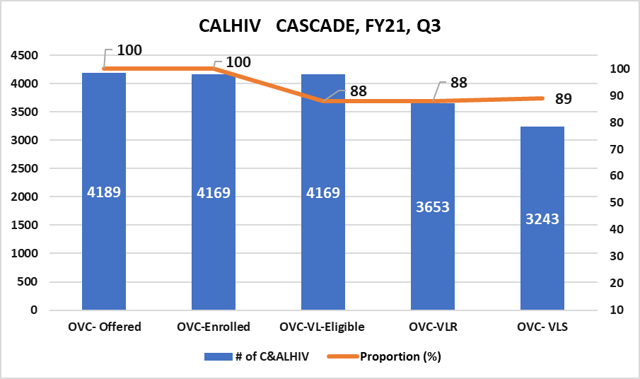

3.1.4 Facilitating Linkage to clinical, and socio-economic services
3.1.4.1 Improved and expanded access to comprehensive services for OVC

During this reporting period, 51,498 OVC (<18) reached with one or more services, based on individual needs and case plan implementation. This represents 97% achievement against the target of 53,326 OVC. Additionally, 25,158 caregivers were served directly and/or through referrals, as per their care plan, which is much higher than the targets for the FY. The caregivers that are enrolled in the program deviates from the target as this number depend on the number of enrolled OVC and households.
Therefore, during this reporting period, the total OVC beneficiaries benefited from FFHPCT activities with the comprehensive case management interventions were 76,656, which accounts 98% of all the enrolled 78,484 OVC and primary caregivers.
Among the packages of services, the main services these beneficiaries received include health, HIV (e.g., testing, VLS, adherence follow-up, LFTU, counseling), child safeguarding interventions (e.g., violence screening, creating access to packages of services to survivors of violence), parental support, and clothes, food items. Additionally, the 9-14 years old adolescents participated in time-limited, curriculum-based trainings to reduce risks to sexual violence and HIV.
In the reporting period, additionally, FFHPCTA served 41,574 (78%) 9-14 years old adolescent girls and boys with single time-limited curriculum-based trainings including IMsafer (COVID-19 version), Sinovuyo and CBIM.
Figure 14: OVC-SERC Disaggregated by OVC Comprehensive and Preventive FY21, Q3
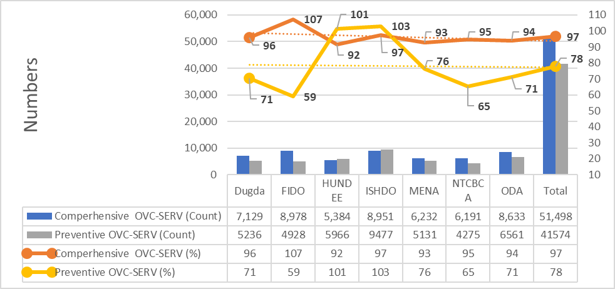
In this reporting period, performance of provision of comperhenscive packages of services to OVC varies across IPs – FIDO, ISHDO and Dugda have served majority of the OVC they have enrolled . The variation is 92-107%. The least being Hundee with 92% OVC servd and the highest being FIDO with 10&% OVC Served .The oevrall rate for OVC served is 97%
With regard to primary prevention , HUNDEE, and ISHDO has done and extraordinary effort served 100% of their annual target for primary prevention with single, time limitted curriculum based interventions despite the tactors that affect community structures to other tasks like the National Election. FFHPCT team including IPs staff and their community based workers made a concerted effort to achive this performanceand had also focused on foundational activities which were necessary for accerelated service provision particularly to compensate wasted time of the primery intervention during trainings of facilitators including IMpower instructors, Sinovuyo coaches and faciliatators.
3.1.4.2. Extended HIV/AIDS Services for OVC

During the reporting period, 51,498 OVCs were served with the package of PEPFAR OVC services based on their need indicated in household case plans. The 99.8 % of active children had a known HIV status. Of these 45,578 (88.7%) are HIV negative, 2,555 (7.2%) did not require HIV test based on risk assessment, and 3715 (5.0%) are HIV+. The OVC with unknown HIV status was only 124 (0.2%).

Figure 15: USAID FFHPCTA OVC Received HIV Services OVC-HIVSTAT, FY21, Q3.

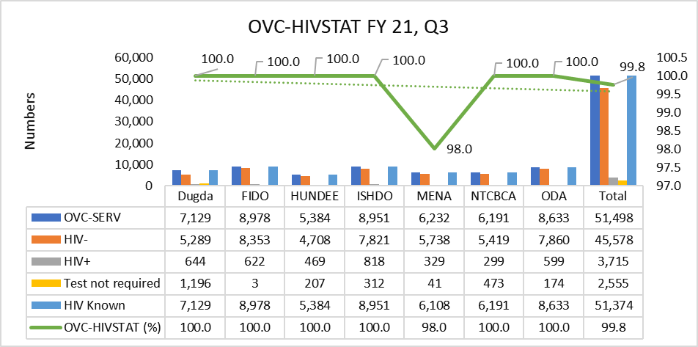

3.1.4.3 Pediatric psychosocial support training delivered to IPs staff

During this reporting period, ISHDO prime has organized pediatric psychosocial support training to 47 Implementing partners staff including CEFs, OVC Specialists and Care & support officers.
The overall objective of this training was to equip participants with important information, skills and attitude that will help them to maximize resiliency, minimize risk factors and promote positive personal growth among C&ALHIV.
The materials used in this training was the National Pediatrics Psychosocial support participants manual and Peer groups lesson plan. Additionally, testimony of C&ALHIV from Adama Hospital was part of the training. Furthermore, visit was conducted to see the actual peer support program conducted at this hospital. Sanitizers and strict adherence to mask use was maintained throughout the PPSS group training and visits.
Generally, the achievement of the trainees in the pre and posttest assessment was excellent. The mean score of the pre-test and the post-test were 68.8 and 89.4 respectively. The post test result shows that the trainees have improved in about 20.7 points on average from the pretest assessment

3.1.5 Engaging OVC beneficiaries into economic strengthening services

During the past three quarters, FFHPCTA supported a total of 5,905 caregivers with ES services, which is 95.7% of the annual target of 6,172 and achieved a 14.1% increase from Q1 and Q2.
This reporting period was marked with a continued focus on reaching caregivers with HIV-positive children and HIV positive caregivers both through health facilities and communities. Based on their willingness and livelihood pathways, the caregivers were provided with services through social protection, VSLAs, asset transfer and linkage with financial services providers. FFHPCTA continued supporting members of VSLAs established in the past two quarters by facilitating linkages with formal financial service providers and Business Development Services.

3.1.5.1 Caregivers’ VSLAs establishment

During this reporting period, 43 new VSLAs were added to those already established in the last two quarters of the year, bringing the total VSLAs established in FY21 to 154 (71%) achievement against the annual target of 217. The newly established VSLAs were provided with VSLA kits, and trained in savings, loan management, record keeping, development of by-laws and other procedures.
Those previously established continued to receive technical support in this quarter to ensure VSLA standards are maintained, and to support them on the path to graduation. FFHPCTA also continued to layer HIV and health services using the VSLAs as a platform including index case testing, disclosure counseling, cervical cancer demand creation, GBV screening, adherence literacy education and so on. See in Figure 16 below performance of VSLA groups formation of IPs. Hundee and FIDO reached beyond their annual target, because they revised their target to serve additional targets using their OVC budget appropriately. However, ISHDO and Dugda were less preforming IPs. They received VSLA training in this quarter and planned to execute this activity in the next quarter.
3.1.5.2. Caregivers Engaged in VSLA and support

During this reporting period, all IPs were intensively engaged in reaching out caregivers of HIV-positive children and caregivers using the VSLA intervention. In Q2, mostly preparatory activities were undertaken, including conducting HHEVA and holding orientation sessions with health facility and community. With the support and coaching of ISHDO OVC teams, in Q3, 3,063(70%) caregivers trained and engaged in VSLA.
Cumulatively, in two quarters 5,275 (121%) HIV+ and caregivers of HIV+ children were benefited from VSLA intervention using the health facility and community platforms.
VSLA members also established a separate social fund with the purpose of supporting children’s educational expenses and medical emergencies. Similar to VSLA formation, most IPs (Eg. FIDO, Hundee, NTCBCA and MENA) reached beyond their annual target, because they revised their target to serve additional targets using their OVC budget appropriately. However, ISHDO and Dugda were less preforming IPs. They received VSLA training in this quarter and planned to execute this activity in the next quarter.

3.1.5.3. Direct asset transfer support

FFHPCTA asset transfer intervention primarily targets HIV+ and caregivers of C/ALHIV who are destitute but active OVC caregivers and youth who are not covered by any other government safety net or social protection schemes.
In quarter three, FFHPCT provided asset transfers to 324 (17.7%) caregivers to equip them with productive assets which will help caregivers generate income, and cover the basic household necessities of food, schooling and medical expenses.
Cumulatively in the past three quarters, 630 (34%) caregivers have benefited from this intervention. FFHPCT Activity planned to accelerate implementation of this intervention to address diverse needs of C/ALHIV. Tools and packages devised and ES training delivered to accelerate to support and implementation of asset transfer and linkage to government social protection programs to meet annual target. MENA and ODA identified asset needs of destitute households eligible to asset transfer and facilitating procurement. FFHPCTA developed acceleration plan and following and supporting implementation in weekly basis.
The most common productive assets provided include: small size food processing equipment, agricultural tools and merchandise based on their business plans to generate income and improving household consumption. The asset transfer has enabled destitute caregivers to establish small and micro-enterprises with a potential to achieve a long-term economic stability and resilience building, which contributes to adherence to ARV and VLS.

3.1.5.4 VSLA capacity training to IPs staff and ES Animators

During this reporting period, ISHDO prime team has organized and provided VSLA training at Bishoftu town from June 22-26,2021 to 45 participants. The participants included 32 ES Animators, 7 program coordinators and 6 ES officers. The participants are expected to cascade this training to train caregivers on VSLA establishment, savings, loans, micro-enterprise selection, bookkeeping and records. The purpose of the training was to provide the necessary skills to enable IPs staff and ES Animators to form Village Savings and Loan groups in their target SNUs.
The workshop was composed of lectures/presentations and a field visit. The
first four days focused on power point presentations and discussions while the 5th day
focused on a field visit to a VSLA group in Bishoftu. The trainees were taken through the VSLA concept, overview of VSLA, importance of VSLA, and VSLA Modules.
Table 4: VSLA training participants FY21, Q3
S/N | IPs Name | Project coordinators | ES Officers | ES Animators | Total
1 | DUGDA | 1 | 1 | 6 | 8
2 | FIDO | 1 | 1 | 3 | 5
3 | HUNDEE | 1 | 1 | 4 | 6
4 | ISHDO | 1 | 1 | 9 | 11
5 | MENA | 1 | 0 | 3 | 4
6 | NTCBCA | 1 | 1 | 2 | 4
7 | ODA | 1 | 1 | 5 | 7
 | Total | 7 | 6 | 32 | 45

Sub IR 3.3: Improve primary prevention of sexual violence and HIV training and services to 9-14-year-old girls and boys.

The objective of the primary prevention intervention include: (1) to reduce risks of sexual violence among adolescent boys and girls aged 9-14 years and (2) reduce the risk of HIV among adolescent boys and girls aged 9-14 years and (3) to build the capacity of parents to enable them to create a protective environment for their children. To meet these essential objectives FFHPCTA was facilitating trainings with adolescents using IMpower (COVID-19 version-named IMsafer), Coaching Boys into Men (CBIM) and parenting for Lifelong Health (Sinovuyo) curriculum using community and school platforms.
To ensure quality of the training Woreda Education Offices, and School principals were oriented and engaged during implementation of these curriculum.

3.3.1 Parenting for Lifelong Health (Sinovuyo) capacity building activities.
In this reporting period, 14 Sinovuyo facilitators have received the 5-days Sinovuyo Facilitators basic training virtually by FHI360 in collaboration with CWBSA. Following the basic training these facilitators commenced facilitating Sinovuyo teens training with adolescents (9-14 years boys and girls).
Additionally, the 30 certified coaches were imparting practicum coaching and supervising the above 14 facilitators. They were receiving coaching support and group webinars from global trainers of CWBSA to be certified as coaches.

ISHDO in collaboration with FHI360 facilitated certification assessments of competency of 12 coaches based on coach’s supervision and mentoring video which was the criteria for qualification to certify these coaches. The assessors evaluated the proficiency of these 12 coaches and certified 10 (83.3%). The remaining 18 coaches are waiting for assessment results, videos are under assessment by CWBSA.

    - Coaching Boys into Men /CBIM/ trainers capacity building support
CBIM is one of the PEPFAR approved prevention curricula. It was recalled that as part of rolling out the curricula 276 physical education teachers (PET) has been selected to facilitate this training and received CBIM training in the last quarter. During this quarter, on top of the training of beneficiaries, quality of CBIM training maintained through intensive supervision by technical support from ESSSWA, ISHDO. Gap observed during the trainings were provided with onsite feedbacks communicated to Physical Education Teachers, particularly on implementation strategies and M&E tools. Additionally, SSWs were placed at schools to facilitate service referrals to survivors of violence disclosed their status.

3.3.3. IMpower/IMsafer Instructors training
IMpower is proven system of violence prevention, intervention and recovery. The female Impower instructors learn and teach IMpower to adolescent girls of 9-14 years old, that
imparts mental, verbal and physical skills.
In the reporting period, to meet this objective, the 11 previously certified TOIs delivered 3-weeks Impower training to 386 female instructors. Of this, 280 (73%) met the minimum instructors certification criteria of the curricula and certified. See in the figure below distribution of certified instructors by IP. These instructors are sufficient to meet annual targets.
Table 5: IMpower certified instructors, FY21, Q3

LIP | # Of instructors trained | # Instructors Certified | % Instructors Certified
Dugda | 60 | 38 | 63
ODA | 60 | 24 | 40
NTCBCA | 30 | 26 | 87
MENA | 56 | 24 | 43
ISHDO | 60 | 57 | 95
HUNDEE | 60 | 57 | 95
FIDO | 60 | 54 | 90
Total ISHDO | 386 | 280 | 73

3.3.4. Adolescents Served using time-limited curriculum-based trainings

In the reporting period, FFHPCTA served 41,574 (78.0%) adolescent girls and boys using the trained Impower instructors, Physical education teachers and Sinovuyo facilitators.
Among these children, 26,346 (63.4%) completed the 12 sessions of CBIM; 12,874 (31.0%) received the 4-sessions of IMsafer and 2,354 (5.7%) of adolescents completed 14 sessions of Sinovuyo teens curricula.
Both community and school platforms have used to deliver preventive services to these adolescents. The remaining 11,752 (22.0%) 9-14 years adolescents of the annual target are under training by this time. ISHDO will reach the annual sexual violence and HIV prevention target before July, 2021 turned-out.

Figure 16: USAID FFHPCTA IMpower/IMsafer, CBIM and Sinovuyo Teens trainings to 9-14 years old adolescents FY21, Q3

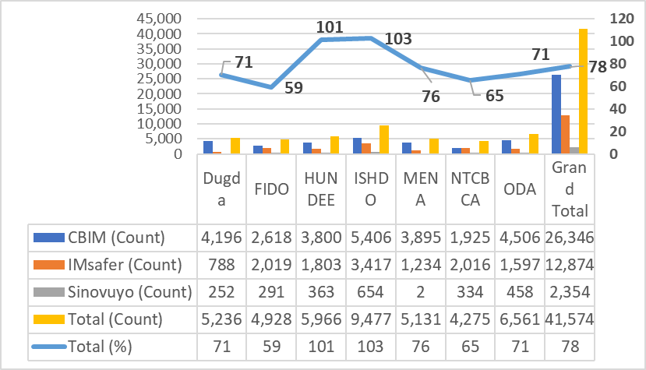
Result 2: Strengthened utilization of data to monitor service delivery and conduct quality improvement of program services
IR 2.1 strengthening data use through the Implementation of Unified Data System

2.1.1 Utilizing USAID Unified Data System (UUDS)
ISHDO has been closely working with Project Hope to further expand and optimally utilize UUDS for routine program monitoring, case management, and quality improvement. Accordingly, ISHDO has identified focal person from each IPs responsible for the data entry, established location hierarchy of partners and completed all the preparation for smooth data entry into the commcare system. Through the established collaboration ISHDO M&E closely worked with PH to solve challenges faced during day-to-day implementation.
ISHDO has facilitated virtual trainings on UDS and commcare to all IPs to provide basic knowledge of the use of the system and its implementation.

2.1.1.1 Commcare cascading activities

Project Hope provided a One-day M&E functions training on Commcare for M&E experts at all LIPs including head office M&E and technical team members for 13 staffs (11 male, 2 female) at June 30, 2021. A half day training on basics of Commcare training was provided by FFHPCTA internal staff on June 5, 2021 for 46 newly recruited CEFs in Adama town.
ISHDO M and E team has provided technical support on commcare utilization through site visit, email and phone communication. In the reporting period, IPs have entered different project data into commcare as per the indicators provided.
In addition, challenges related to flitter mechanism, blank form, data cleaning on UDS were discussed with PH team and resolved in the reporting period. Subsequently, we shared all guidance related to the issues that received from PH to LIPs. Following these guidance, M and E team started serious follow up to ensure the quality of data in UDS.
Through communication with PH team in the reporting period 6 new accounts created, 2 old accounts closed; moreover, 5 web access created to M and E team and technical staff.

2.1.2 Equipping and data management

ISHDO closely worked with PH to find out solutions for recurring Commcare related issues raised during FY21Q3. Based on the feedback given there are few revisions: test date inserted for Community based testing, self-testing and health facility testing and also for OVC_PREV, start and end date are inserted to CBIM, Sinovuyo and Impower. This simplifies few ambiguities on Commcare data analysis.

IR 2.2. Improve quality of community HIV services

2.2.1 Program quality assessment and improvement
ISHDO FFHPCT collaborated with Accelerated Support to advanced Local Partners (ASAP) for a Three-day Adapted Basic Quality Improvement training by from June 20-22, 2021.
A total of 7 ISHDO prime & ISHDO-sub staffs (2 male & 5 female) staffs participated in the training. Following the training all LIPs including ISHDO prime reinforced the functionality of QI team, revised TOR and started to conduct meeting regularly and begin implementing different QI projects.
The QI/QM design follows the Plan Do study Act/PDSA cycle approach and there was a total of 8 QI projects being implemented. Few of the QI projects were: Improving Data Quality, improving CAG & PCAD group formation, improving C&ALHIV enrollment, increasing case findings/yields and increasing Viral Load Testing. There are about 3 QI project in increasing CAG & PCAD group formation as this was the major under performance identified during the reporting period.

2.2.2 Conduct routine data quality assessments
Besides the JISS provided by ISHDO Family Focused HIV Prevention Care & Treatment/ FFHPCT Activity, the M&E team conducted RDQA for 3 LIPs (ISHDO-sub, DUGDA, MENA) in 1SNUs (Batu, Shashemene, Assela, Adama, Bishoftu, Sebeta, Woliso, Burayu, Dukem, Goba and Meki). RDQA action plan provided and implementation followed continuously. Documentation was emphasized during the RDQA visit and LIPs are technically supported to prepare a file folder for JISS, RDQA and Performance review meetings

2.2.3 Collaboration Learning & Adaptation
ISHDO FFHPCT Activity conducted Semi-Annual Performance Review Meeting in April 2021. As part of the review meeting best practices of selected LIPs were presented and lessons were shared to tall partners. This internal cross fertilization of best practices was a good scenario to initiate other LIPs to document their success and encouraged to share for others. ISHDO FFHPCT Activity required a minimum of 1 best practice for each LIP to share as part of the quarterly report and hence LIPs gave due attention to its documentation.

IR 2.3 Monitoring, Evaluation and Reporting
2.3.1 Monitoring & Evaluation
2.3.1.1. Joint Supportive Supervision and Technical Assistance

ISHDO FFHPCT Activity prepared Joint Integrated Supportive Supervision checklist jointly with cluster office staffs. The JISS checklist is pilot tested during the supervision period. Internal Joint Integrated Supportive Supervision was conducted from May 11- June 4, 2021 by ISHDO head office and cluster office team in selected nineteen SNUs (Batu, Shashemene, Assela, Adama, Adama Zuria, Bishoftu, Sebeta, Woliso, Burayu, Dukem, Jimma, Nekempte, Metu, Robe, Adola, Shakiso, Goba, Meki and Boset).
The purpose of the supervision is to review all programmatic activities using standardized supportive supervision checklist. This Joint Integrated Supportive Supervision set a baseline for the selected SNUs using dashboards. Moreover, the JISS checklist were revised based on findings from the field visit. For the next visit, the dashboard will be updated accordingly and progress will be documented. The team has provided on site oral and written feedback and recommendations on gaps observed. The supervision and feedback session involved town government stakeholders from health office from respective towns. Use of proper and standard M&E tools, conduct RDQA regularly, positive verification before reporting & regular reporting to Town Health Offices.
2.3.1.2. Performance Review Meeting

ISHDO FFHPCTA conducted the regular quarterly Performance Review Meeting from April 26 to 27, 2021 in Addis Ababa. A total of 50 participants from all sub-partners and ISHDO team attended the review meeting. This quarterly review meeting focused in reviewing FY 21 Semi Annual Performance review with a purpose to review key project achievements, areas of improvement, challenges on implementation and planning for the next quarter. Moreover, the review meeting helped to discuss in detail what were implementation challenges at each SNU. On the second day, planning discussion held thoroughly and that was a good opportunity to share ideas how to implement FFPHCTA in FY 21 Quarter III considering the discussion we had on our past performance & challenges encountered.
3. Subaward Grant Management:
3.1 Subaward Monitoring:
A compliance review was conducted in Quarter 3 at subrecipients to ensure costs incurred are complying with USAID standard provisions. The compliance site visits include review of financial management, accounting recording and system, procurement and human resource and internal control of the implementing partners.
The Subaward monitoring focused in strengthening internal control of subrecipients and ensures compliance of USAID rules and regulations.
In addition, the Grants and compliance team provided technical assistance to Subrecipients finance and grants staff at site level. The gaps identified during the subaward monitoring site visits were discussed and corrective actions were prepared with timeline.
The major findings identified during the visits includes:
- Ineligible costs due to lack of supporting documents;
- Non-compliance of USAID VAT reimbursement procedures;
- Fuel consumption analysis not conducted to strengthen the internal control of vehicle operations;
- Noncompliance of procurement polices and procedures and incomplete procurement documentation
- Incomplete Human resources documentations and absence of staff acknowledgment code of conduct and certifications.
The Grants and compliance team provided follow up support and check the progress of corrective actions taken. The current compliance review results will inform the next quarter subaward monitoring plan focus areas. Furthermore, discussions will be held with subrecipients senior management based on the issues identified.
  - Subrecipients Financial Report Review:
Subrecipients financial reports and supporting documents were reviewed to validate costs reported by Subrecipients are allowable, reasonable and allocable. In addition, the Subaward expenditure verified against invoices and financial documents. The Subaward tracker is used to check subrecipients expenditure is in line with the approved Obligated budget.

  - Subrecipients Advance Request:

Implementing Partners have received their advance for Quarter 3 on monthly basis. The advance payment mechanisms ensure in maintaining thirty days advance is always available at implementing partners for smooth project implementation.
The key challenge in maintaining the subrecipients advance payment system is a delay in getting monthly advance from USAID finance. The project submitted liquidation of advances with in 10 days after the reporting period by compiling subrecipients costs, but monthly advance received often after the end of the month. For instance, April 2021 advance received first week of May and May 2021 advance was cancelled as the month has already ended before the advance request released. This is a persistent challenge affecting the project implementation and exposed the project for serious liquidity problem and has implication in availing the required fund to the subrecipients.

  - Subrecipients Finance Management and Compliance Training:

FFHPCT team has conducted a subrecipients financial management and compliance training June 17 and 18, 2021. A total of 15 participants attended from six subrecipients. The participants were Subrecipients finance and grants staff at their head office and field offices.
The objective of the training was to increase organizational capacity of the trainees in the area of financial management, grant management and compliance to USAID rules and regulations and internal policies and operating manuals. The topics covered in the training includes understanding of USAID cooperative agreement, USAID cost principles, basic polices and procedures (financial management, procurement, property management and human resources policies). The two-days sessions enabled trainees to be well acquainted with the basic understanding of grant and financial management and compliance.

7. Challenges, Constraints and plans to overcome them reporting period
7.1 Quarterly challenges and Constraints for each program area
Even though there are improvements, a great deal of the challenges from the previous quarter remains an issue and is listed below:
Community HIV Care and Treatment
Case finding through ICT
- Low testing positivity for clients recruited from community
- High volume but low HIV positivity for children
- Low overall testing volume
Case finding through HIVST
- Low utilization of HIV self-test kits.
Geographic Hotspots
- Low testing volume in known geographic hotspots like Adola
Ensuring adherence of ART clients
- Limited tracing and identification of LTFU
- Collaboration with faith-based organizations not started
- Implementation of case management in CHCT only SNUs not started
Implementation of community-based differentiated care model
- Low uptake on establisment of CAG
OVC comprehensive care
- Poor integration of the CHCT and OVC services activities due to low capacity by social service workers and caseworkers.
- Limited resources in the community to address unmet needs of beneficiaries:
- COVID-19 pandemic has reduced in person service delivery by case workers with regular home visits.
- Political unrest in some SNUs restricted in person technical supports and supportive supervisions.
- Community structures and trained PE teachers were shifted their focus into the National Election. This has affected the OVC comprehensive service delivery to OVC and preventive interventions performance of the program particularly CBIM.

7.2 Plans to overcome challenges
Community HIV Care and Treatment
Case finding on ICT

Job coaching to CEFs and volunteers on the correct use of risk assessment that prioritizes testing of children of newly diagnosed parents and sexual partners of index cases having with high viral load or repeated episodes of poor adhernece

Finaliztion of establishment of testing corner for CEFs in SNUs with newly deployed CEFs
- Improving collaboration with OVC workforce to identify eligible contacts in OVC households by training Care and support officers and SSWs
Case finding through HIVST
- Maximizing utilization of self-test kits especially during outreach testing by focusing on refusals and those reluctant to be tested
Geographic identification of Hotspots

Provide special support for known hotspots by like Adola, Shakiso, and Negele by accelerating identification of missed opportunities in ICT
Ensuring adherence of ART clients
    - Maximize the engagement of PLHIV association and faith-based organizations in tracing of LTFU cases from Churches and worshiping places by collaborating with IRCE
    - Implement CHCT case management in CHCT sites to promote adherence among CLHIV, newly diagnosed cases, and PLHIV with High Viral Load

Implementation of community-based differentiated care model
- Finalising cascading of training to health care workers, HEWs, and peer ledears
- Establish regional TWG to implement community DSDM models and ensuring involvement and endorsment of ORHB.
Comprehensive OVC Services
- Training and onsite coaching to community structures (CCCs) on guidelines, resources mobilization and services referrals.
- Strengthening coordination of communities and health facilities to enhance accessibility of services to beneficiaries.
- Utilize COVID protection and mitigation measures and ensure service delivery continues maintaining COID prevention measures, keeping physical distances and wearing mask. frequency of home visits by case workers.
- Implement weekly virtual meetings to address barriers of OVC service delivery and ensure diversification of services.

8. Data Quality issues during the reporting period

Data Quality issues and how they were addressed during the reporting period

During the reporting period, data quality issues were observed in the process of case management and CHCT activities. Among the data quality issues observed, the major quality issues were
- All index contacts in line list received from health facility not entered to Commcare
- Index case contact line list received incomplete to document and to trace the clients
- Clients tested at community by conventional testing not documented on conventional testing register and they were only documented on tracking register
- Feedbacks from health facility not received on time
- Discrepancy occurred between ICT line list received, tracking register documentation, Commcare data entry and source document
- There was no line list for CRP, conventional testing register, HIVST register, referral service register
- Updated format not available in hard copy except soft copy at M&E level
- Reports not shared to Zonal / Woreda health office even if they perform conventional test
- SNU M&E not well organized, data not reviewed, analyzed & used at lower level regularly
- Data were not verified and reviewed before sending to the next level
- All case management data not entered into Commcare
- Blank values in reported services
- Incomplete data in submission of Case Management process
- In appropriate sub population categorization
- Delay in reporting
What you are doing on a routine basis to ensure that your data is high quality for each program area?
- FFHPCTA provided orientation and continuous communication with IPs regarding gaps and errors and sharing recommendations and instructions for improvement. Moreover, ISHDO technical staff jointly worked on the data quality issues and address accordingly.

In addition, technical staff follows up with each IP and provide technical assistance to ensure that the gaps are addressed and records are updated.
- The M& E team continued to provide reminders to IPs and ISHDO technical staffs ensure that appropriate data collection forms, including referral forms, are used and completed accurately. The staff continues to monitor progress and to provide assistance during monitoring and supportive supervision visits.
How you planned to address those concerns / improve the quality of your data for each program area
- M & E team has prepared and shared data verification tool to avoid/minimize data quality issues during implementation of acceleration plan; conducted data verification at field level, via desk review, specifically looking at enrolment and HIV STAT database of the activity.
- Feedback was provided to IPs on the corrective actions to improve the data quality.
- FFHPCTA will undertake field visits to supervise, coach and mentor the M &E team on data quality and routine data quality assessment will also be rolled out during this time

9. Major Activities planned in the next reporting period

Result 1
Community HIV care and treatment
Trainings will be provided for CEFs, case workers, and technical staff:
- Ensuring EQA participation of all CEFs
- Maintaining on job coaching of CEFs for case finding
- Accelerating case finding and DSDM activities done through integration with OVC activity
- Finalizing CHCT case management enrollment
- Accelerating cooperation with IRCE and NNAPWE to coordinate care and support activities
Comprehensive OVC programming
- Training IPs on additional packages of services, tools and priorities to C/ALHIV
- Monitor and support rollout of economic strengthening & CCCs trainings and service delivery based on case plans to beneficiaries.
- Facilitate orientation training to IPs (e.g., SSWS & CWs) on graduation benchmarks, readiness assessment and case closure tools to facilitate exit of families met minimum graduation benchmarks.
- Prioritize enrolling new HIV+ children as well as boys and girls aged 9-14 years.
- Deliver direct technical support to improve service diversification based on case plans and quality of services delivered to OVC.
Primary Prevention to 9-14 Adolescents
- Cascading sexual violence and HIV prevention trainings (e.g., CBIM, IMpower) to 9-14 years old adolescents.
- Train IMpower Instructors to deliver the training to adolescent girls (9-14 years)
- Analyzing pre-post assessments of CBIM and IMpower trainees to generate evidence.
- Facilitate facilitators (e.g., CBIM trained PE teachers) acknowledgement workshop to ensure retention and reduce burnout.
Result 2: Strengthening Monitoring and evaluation and quality
- Ongoing Supportive supervision, review meetings and RDQA
- Ensure the better functionality of commcare application in collaboration with PH and ensuring real time data entry
- Tracking QI project implementation

11. Financial accomplishment

(… in USD)
Life of Activity budget  (a) | Obligated  to date  (b) | Expenditure  (Accrual and actual disbursement)  to date  (c) | Remaining balance  (d) = (b) – (c) | Remarks
9,948,804.00 | 3,316,268.00 | 1,995,650.00 | 1,320,618.00

12. Issues requiring the attention of USAID Management
- Delay budget transfer from USAID side and modality of transfer needs critical consideration and discussion
- Test kits distribution in adequate quantity has been a real challenge that affects testing performance throughout the year

13. Data Sharing with Host Government:

Have you shared this report with the host government?

Yes
No

If yes, to which governmental office/s?

- Regional Health Bureau

If No, why not?

[Please put your response here]

Have you made data reconciliation with respective regional sectoral office/s?

Yes
No

If yes, to which regional sectoral office/s? Were there any issues that came out from the reconciliation? How these issues were handled/ will be handled?

There is no need for data reconciliation as our sub partners are responsible to do. ISHDO as prime didn’t sign agreement with respective signatories. Only MOU are expected to be signed with major stakeholders which is RHB.

If no reconciliation was made, what are the reasons for it?

[Please put your response here]

14. Appendices

