Yonatan Desse
Addis Ababa, Ethiopia
| Phone: (+251) 969-922149
| Email: yonatandesse12@gmail.com
April, 2022

To whom it may concern
First of all, I would like to say thank you! Because of your notice makes me to write this letter with interest. Please regard this as an application letter for a place in your institution for the position of Medical Laboratory Technologist.
As a COC-licensed Medical Laboratory Technologist (MLT), I offer a strong match to the qualifications you are seeking for your lab technologist opening. I am a BSC degree graduate from University of Gondar Collage of Medicine and Health Science Department of Biomedical and laboratory Science. In medical laboratory school for the past four years, I worked under variety of laboratory departments facing a number of challenges, but I managed and worked on medical lab operations that include: Collecting, processing and testing specimens per appropriate techniques and clinical protocols, gathering patient vitals and patient history information such as medications and allergies, documenting lab data, test results, and make analysis, operating lab equipment including centrifuges, dry bath incubators and blood bank refrigerators. I have helped many patients when I worked in hematology, parasitology, urinalysis, microbiology, blood bank, histopathology, reception, ART, serology and clinical chemistry laboratories. I am enthusiastic, dedicated and eager to take on new responsibilities and challenges. I am applying for this position , because I feel that I’ll be able to make a difference in the lives of patients on daily basis, I’m confident my passion for Medical Laboratory will grow because of the opportunities you provide for your employees. I would be very glad and will be so productive if you will assign me in your institution and I will strive for continued excellence. I would be trying my best for the success of your institution by fulfilling the duties and responsibilities of my profession on which I am going to be appointed. I will attach relevant document and curriculum vitae and I will make any documents available as soon as requested.
Hence, I kindly request you to give me the opportunity of the employment. I have attached the copy of my documents with this letter. Thank you for taking the time and consideration.
Sincerely,
YONATAN DESSE

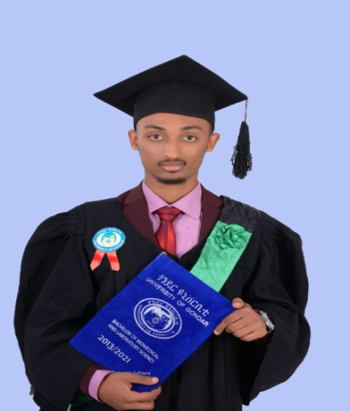
CURRICULUM VITAE

Yonatan Desse Assefa
Addis Ababa, Ethiopia
+251969922149 | yonatandesse12@gmail.com

PERSONAL DETAIL
Date of Birth: 15-01-1992 EC | 26/09/1999 GC
Marital Status: Single
Nationality: Ethiopian
QUALIFICATION SUMMARY
As a recent graduate, I am seeking a role which allows me to continue learning and perfecting my skills as I provide high-quality work, and encourages me to flourish as a Medical Laboratory Technologist.

EDUCATION
University of Gondar

September 2010 – October 2014 for four years

Bachelor of Science Degree in Medical Laboratory Science
GPA – 3.00
Falcon Academy
2006 EC -2009 EC
El-Bethel Academy
1998 EC – 2005 EC

SKILLS
Computer Skills: Microsoft Word, PPT, Excel & Most Social Media
Languages: Excellent in Amharic & English
Soft Skill: Patience, outstanding time management, team building & organizing, Great leadership, Co-operative manner, public speaking & being open to feedback.

INTERSTS
Reading Books
Participating in Voluntary activities
Playing football
Writing

VOLUNTEER EXPERIENCE
- One of the founding Member of Ethiopian Medical Laboratory Science Student Association (EMLSSA) in Debrezeyit
- One of the founding Member of Ethiopian Health Professional Student Association (EHPSA) Gondar Branch
- Served as President of Graduation Committee for 2021 Graduating Batch
- Active participation in Agape Family Charity Volunteer Association as Vice President for 4 years
- Served as a Site Leader during out Team Training Program (TTP)
- Class Representative for 4 years
- Active participation in Sankofa Reading Association
- Active participation in blood donation campaigns (9 times since 2009 EC.)
- National Blood Bank Service of Ethiopia voluntary practice from July 20/2019 to August 30/2019 G.C
- Actively Participate in Rotaract Club of Dejen founded in University of Gondar
- Worked and assisted in a private clinic for 10 month during Covid-19 Pandemic while I was 3rd year student

REFERENCE
1. Mr. Bamlaku Enawgaw, (MSC, Associate Professor of clinical Hematology)
Head, School of Biomedical and Laboratory Science
Mob no: +251913150239
Email: bamlak21@gmail.com
2. Mr. Tesfaye Hambisa (MPH, Assistant professor)
Coordinator, Team Training Program
Email: tajan2022@gmail.com
3. Mr. Teshiwal Deress (BSc, MSC)
Quality Assurance and Laboratory Science
Mob No: +251921638642
Email: teshiwalderess@gmail.com
4. Mr. Elias Shiferaw (BSC, MSC)
Lecturer in the department of Hematology and Immunohematology
Mob No: +251927607075
Email: eliasshiferaw2008@gmail.com
5. Mr. Aberham Abere(BSc, MSc)
Department of Medical Parasitology
Email: aberhamabere21@gmail.com
Mob No: +251918477210

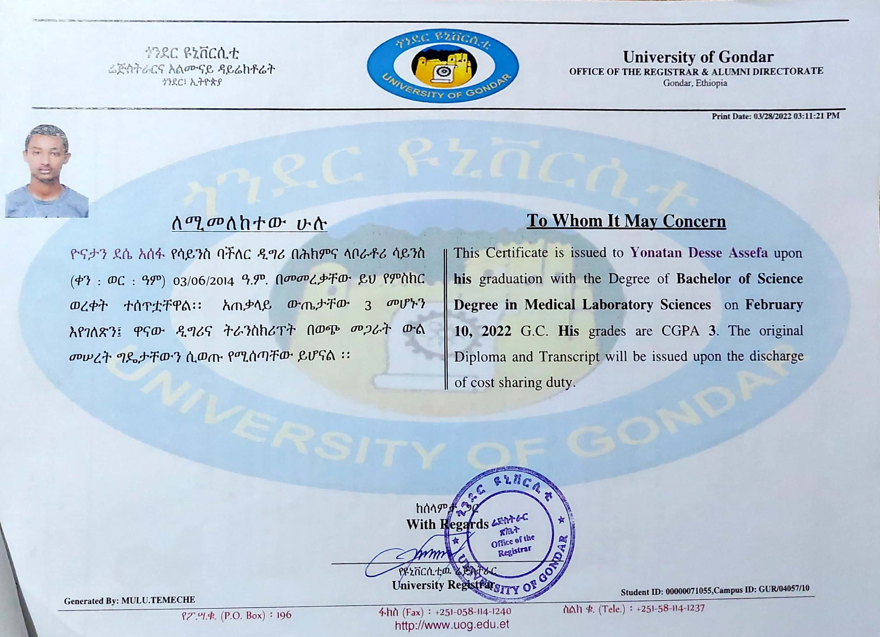
(Tempo)

